The Role of Communication in the Emergence of Surprises in Bank of Russia Monetary Policy
Alina Evstigneeva, Bank of Russia
evstalina@gmail.com
Yulia Shchadilova, Bank of Russia
juliashchadilova@gmail.com
Mark Sidorovsky, Bank of Russia
mark.sidorovskiy@gmail.com

This draft: February 2022

Abstract

In this paper, we examined how the quality of communication and the general information background influence the predictability of the Bank of Russia's decisions on the key rate. Firstly, we applied textual analysis methods to reviews by professional analysts and to texts of official communication of the Bank of Russia. Secondly, we used regression analysis on the data of the decisions and financial markets. Contrary to expectations, we found evidence that during periods of increased uncertainty the decisions of the Bank of Russia were even more predictable. Moreover, this was not due to verbal interventions by representatives of the central bank, which began to be correctly read by the market only in 2020-2021. Judging by the results obtained, significant information advantage of the Bank of Russia over the market has the greatest impact on predictability, which is a characteristic of central banks at the start of inflation targeting. The difference in the focuses of communication between the market and the central bank has also some influence on predictability.

Contents
Introduction and study motivation 2
1. Bank of Russia monetary policy surprise data and formulation of hypotheses 4
1.1. Surprises for professional analysts 4
1.2. Surprises for financial markets 7
2. The hypothesis of the high role of uncertainty and information shocks 10
3. Miscommunication hypothesis 16
4. The hypothesis of the central bank’s ‘secret knowledge’ 24
4.1. Verification of forecast rationality 26
4.2. Testing the hypothesis of the Bank of Russia’s information advantage 27
4.3. Testing the hypothesis of the impact of monetary policy decisions on analysts’ forecasts 28
5. Policy recommendations 29
6. Conclusions 30
References 32
Annex 1. Bank of Russia decisions and analysts’ expectations 37
Annex 2. Additional details on surprises from financial markets 39
Model 1. Modelling 1-year surprises 39
Annex 3. Assessments of models of the high role of uncertainty and information shocks 41
Annex 4. Verbal interventions of the Bank of Russia before decisions 45
Annex 5. Forecast and forecasting error charts 50
Annex 6. Results of evaluation of the forecast rationality hypothesis 51
Annex 7. Evaluation of regressions for the Bank of Russia information advantage hypothesis 55
Annex 8. Evaluation of regressions for the hypothesis of the influence of monetary policy decisions on analysts’ forecasts 57

Introduction and study motivation
In this study, we present a systematic view of the role of communication in the emergence of surprises in the monetary policy of the Bank of Russia.
We are aware of three papers that have previously raised the topic of the predictability of Bank of Russia decisions. The first is from the IMF, which notes that the Bank of Russia is one of the most unpredictable in the world (World Economic Outlook: Challenges to steady growth (2018, chapter 3)). In the 2010–2018 period, 27% of key rate decisions were not expected by the market. At the same time, the unpredictability of the decisions of other developing countries was noticeably lower: 19% for Brazil, 13% for Turkey and India, and 9% for Thailand. The central banks of the developed countries are very predictable. For example, the US Federal Reserve did not present any surprises in the same period – all of its decisions were expected by the market.
Isakov et al. (2018) continue the topic. Their work also provides data on the share of key rate decisions correctly predicted by analysts, but for the 2015–2018 period, that is, for the period of inflation targeting. The average unpredictability in these years was 35%, compared with 10% for New Zealand (the country is selected for comparison due to its successful experience in publishing the future trajectory of the rate, and this is the main recommendation of the work in terms of improving the communication of the Bank of Russia).
After these studies, the discussion continued at forums and in the media. In recent years, the topic has often been raised in the largest Russian media outlets, both in analysts’ columns and in editorial materials. The controversy tends to intensify after decisions that were predicted by less than half of analysts according to Bloomberg and Reuters polls. At the time of writing, in 2021, there had been three such decisions, out of six decisions in total, in March, April, and September.
Why is the predictability of key rate decisions so important? Comprehensive answers are given in a number of classic works and statements from central bankers on inflation targeting and monetary policy: Woodford (2003), Bernanke (2004b), Blinder (2004), Issing (2005), Trichet (2005), and Blinder et al. (2008). They postulate that the predictability of decisions is an important and effective component of inflation targeting. As King (2000) notes, a successful central bank should be boring. The predictability of decisions speaks to the correctness of the perceptions of economic agents about the central bank’s policies, which, through expectations, contributes to the achievement of the goal of price stability. In turn, effective communication makes a crucial contribution to the predictability of decisions. Blinder et al. (2008): ‘Successful central bank communication should make its policies more predictable and market expectations for future rates more precise.’
In this study, we aim to present a systematic view of the role of communication in the emergence of surprises in the Bank of Russia’s monetary policy.
To do this, we address the following challenges:
- we assess the current level of predictability of decisions separately for professional analysts and for the money market;
- on the basis of the observations made and the approaches available in the literature, we form hypotheses on the possible causes of Bank of Russia monetary policy surprises in terms of the role of communication;
- we test our hypotheses;
- we develop recommendations to improve communication.
This work’s contribution to the literature is its provision of systematic analysis of the predictability of the Bank of Russia’s monetary policy decisions in terms of the efficiency of communication. No such systematic studies have been conducted to date. In addition, we contribute to the literature on the development of tools for textual analysis, modelling the level of macroeconomic uncertainty through a news index and modelling narrative communication gaps between the central bank and professional analysts. The methods proposed may be used in future studies of the efficiency of communication. We also propose methods adapted to the characteristics of financial markets in developing countries for the assessment of central banks’ information advantage, which may be used in the construction of appropriate models for central bank communication in other developing countries.
The work is structured as follows. In Section 1, we assess the current level of predictability of decisions separately for professional analysts and for the money market, comparing it in terms of analysts with central banks at a comparable stage of inflation targeting. On the basis of the observations made and the approaches available in the literature, we form hypotheses on the possible causes of monetary policy surprises. In Sections 2–4, we build models and test our hypotheses. Section 5 contains recommendations to improve communication and the general conclusions of the work.

1. Bank of Russia monetary policy surprise data and formulation of hypotheses
In this paper, we study the following types of monetary policy surprises:
(1) Surprises for professional analysts. A surprise occurs when a minority of experts were able to correctly predict the decision of the central bank.
(2) Surprises for financial markets. A surprise occurs if the rates in financial markets are significantly adjusted within a short period of time following a central bank decision.
We consider the data for each group of surprises individually.

1.1. Surprises for professional analysts
We evaluate surprises for professional analysts (that is, the share of analysts who correctly predicted the Bank of Russia’s key rate decision) according to Bloomberg surveys. A similar approach is used, for example, in the work of Grigoli, Gruss and Lizarazo (2020).
The Bank of Russia moved to inflation targeting starting in 2015. Thus, the most volatile period of 2014 remains outside our study.
In the 2015–2021 period, on average, 32.9% of analysts in the Bloomberg survey could not correctly predict the Bank of Russia’s key rate decisions.
A comparison with other countries is shown in Figure 1. To account for the effect of the duration of experience under inflation targeting, we have taken data for the first six years of the regime from each of the central banks included. As can be seen in the figure, the share of Bank of Russia monetary policy surprises generally corresponded to the average for developing countries, while being significantly higher than that of developed countries (the ECB and the US Federal Reserve). The most unpredictable central banks at the stage of the establishment of inflation targeting regimes were the National Bank of Ukraine and the Central Bank of Brazil. It can be assumed that the high unpredictability of decisions as a whole is characteristic of the stage of the establishment of inflation targeting regimes, when central banks are still only adjusting their communication with the market.

Figure 1. Frequency of monetary policy surprises in the first years after the start of an inflation targeting regime

Periods analysed:
National Bank of Ukraine: 2015–2021
Central Bank of Brazil: 1995–2005
National Bank of Kazakhstan: 2016–2021
Bank of Indonesia: 2005–2011
National Bank of Romania: 2006–2012
Bank of Russia: 2015–2021
South African Reserve Bank: 2001–2007
Reserve Bank of India: 2016–2021
Central Bank of Chile: 2001–2007
Norges Bank: 2003–2009
European Central Bank: 2000–2006
US Federal Reserve: 1998–2004
Source: Bloomberg.
In analysing the predictability of the Bank of Russia’s decisions, we divide by type of event.
First of all, by the principle of maintaining or changing the rate. Were analysts equally mistaken in the case of a rate change and its remaining unchanged? These data are presented in Figure 2. According to the results for 2015–2021, analysts are significantly more likely to make mistakes when the Bank of Russia changes the key rate (on average, 46.27% of analysts could not correctly predict a change in the rate). Decisions to maintain the rate are much easier to predict. On average, only 13.70% of analysts make mistakes. Frequent rate revisions may indicate increased macroeconomic and financial uncertainty.

Figure 2. Monetary policy surprises for professional analysts (orange – decisions on changing the rate; grey – decisions on maintaining the rate)
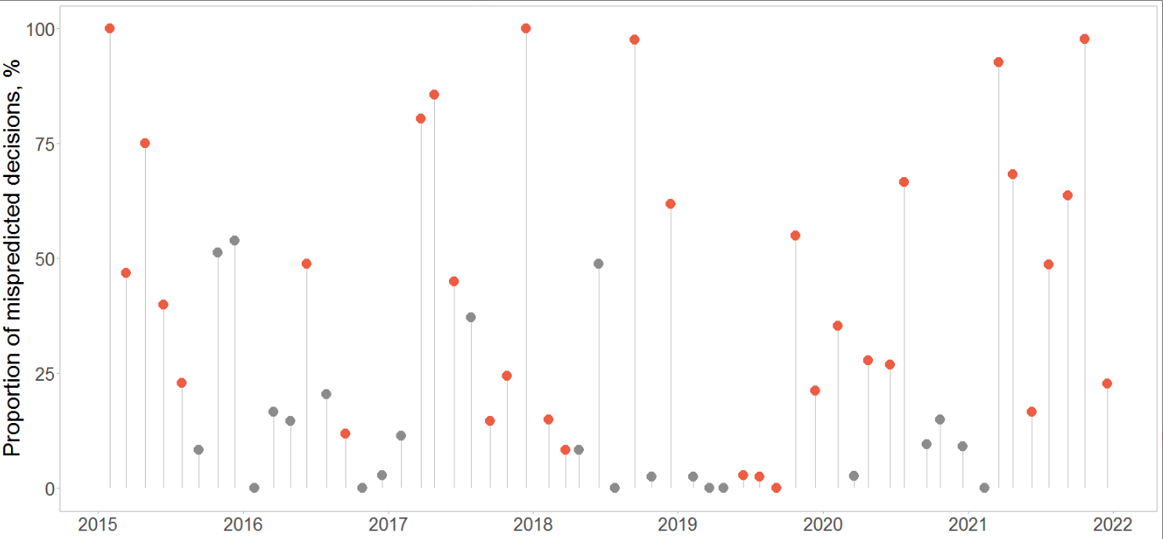
Sources Bloomberg, authors’ calculations.
A second way to divide surprises by event type is by ‘hawkish’ and ‘dovish’ decisions. We consider decisions to reduce the key rate and/or decisions with signals of a future reduction to be ‘dovish’ decisions, while ‘hawkish’ ones are correspondingly decisions on key rate increases and/or decisions with signals of a future increase. Neutral decisions are decisions that give no clear signal of a future decision (data dependent) or signal the need to assess the feasibility of continuing the cycle, or decisions that prepare reversals in policy by stating a strongly changed situation compared to the baseline forecast.
In this comparison, the gap is smaller: analysts make mistakes with ‘dovish’ decisions in 32.16% of cases, on average, in 47.36% of cases with ‘hawkish’ decisions. We attribute this difference to the fact, that almost all our sample is a one big ‘dovish’ cycle from 17.00% in January 2015 to 4.25% in 2020 (37 decisions overall). The ‘hawkish’ cycles both in 2018-2019 and 2021 were much shorter (12 decisions) and therefore more difficult to predict.

Figure 3. Monetary policy surprises for professional analysts (blue – ‘dovish’ decisions; red – ‘hawkish’ decisions; grey – other)
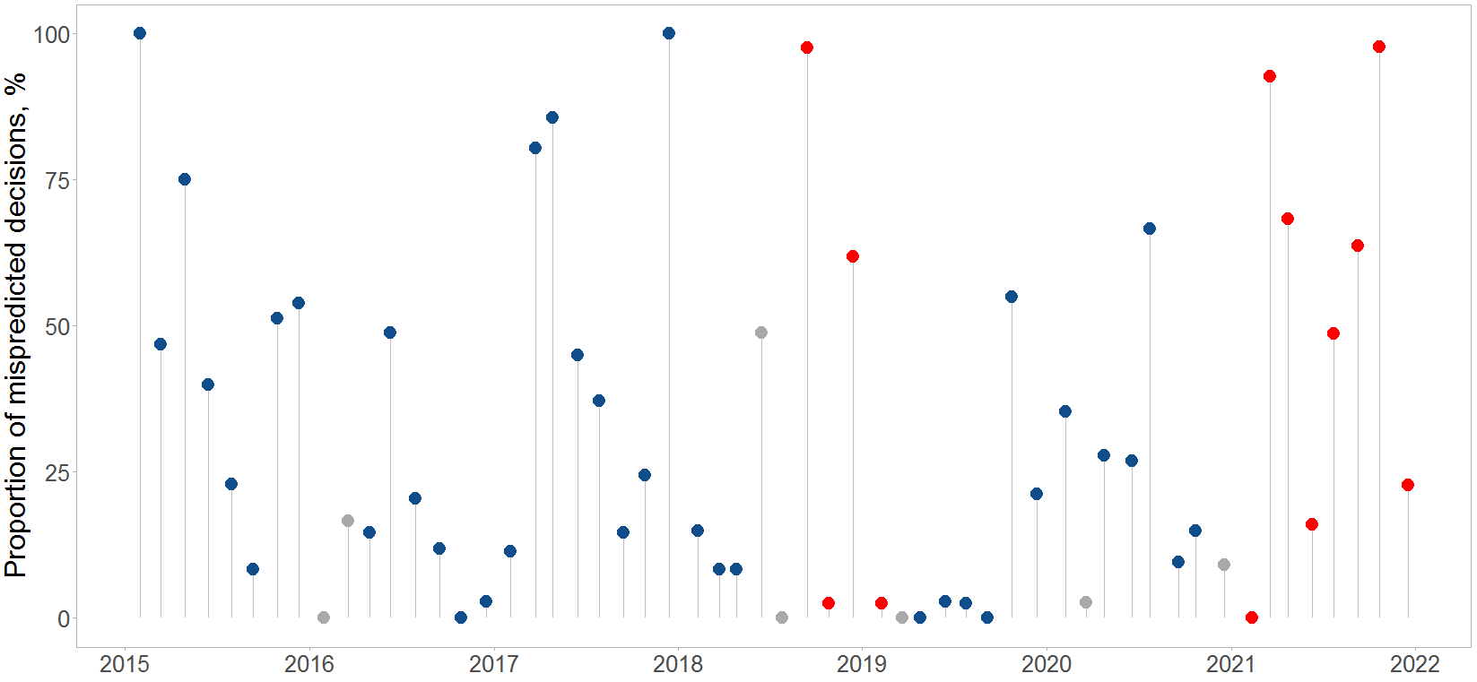
Sources: Bloomberg, authors’ calculations.
Since the start of the inflation targeting regime, we have recorded 15 surprises (cases in which more than 50% of analysts made a mistake in the rate forecast), of which 12 correspond to decisions involving a change in the rate and only 2 to decisions involving its preservation. A detailed list of these surprises is given in Annex 1.
In 11 cases out of 15, analysts expected the Bank of Russia to be more cautious in its decision-making than it was in the end. This may indicate that there are different reaction functions among analysts and at the Bank of Russia.

1.2. Surprises for financial markets
To detect surprises for the financial market, we used a common method of high-frequency event-study analysis, as described, for example, in the work of Kuttner (2001). In this paper, Fed Funds Futures are used to assess the impact of monetary policy on US Treasury bond rates. The author concludes that the impact of expected policy changes on bond yields is zero, while the impact of unexpected changes is high and significant.
Further development of the method is proposed by Gurkaynak et al. (2005), breaking down monetary policy surprises into two components. The first reflects surprise about the decision made directly (target shock), and the second – surprise regarding the future trajectory of the key rate (path shock). The authors conclude that the US Federal Reserve’s actions have a much lower impact on financial markets than its words, especially for medium- and long-term bonds. Buraschi and Whelan (2016) update the results of this study and come to similar conclusions. We follow this approach (breakdown into target shock and path shock) in identifying Bank of Russia surprises.
The impact of monetary policy on financial markets has also been assessed for other central banks. Leombroni et al. (2021) assess the surprises of the ECB, and Pescatori (2018), the surprises of the Bank of Chile. Regarding the assessment of the Bank of Russia’s monetary policy surprises for financial markets, this is partly addressed in the work of Tishin (2019). The author designs a series of monetary policy surprises from currency futures and used them to evaluate the monetary policy transmission mechanism over the 2002–2018 horizon.
It is worth noting that in emerging market economies, the analysis of surprises is complicated due to the lack of a developed and highly liquid derivatives market on the interbank loan rate. In particular, the futures market for interbank lending rate is not as developed in Russia, so we use the ROISfix indicative rate to evaluate monetary policy surprises. The indicator is formulated by the National Financial Association on the basis of quotes announced by the participants in fixing – several of the largest Russian banks. The 1 week to 6 month indicators have been available since 2011, and the 12 month indicator has been available since 2016.
We define a monetary policy surprise as a market rate change during the day of the meeting. Since the ROISfix rate is published in the morning of the each business, we subtract the ROISfix rate on the board meeting day from the rate on the following business day. For most meetings, this is equivalent to:
$Monetary policy surprise={ROISfix}_{Monday morning}-{ROISfix}_{Friday morning}$ (1)
This definition of surprise is based on several assumptions. First, although ROISfix is an indicative rate and reflects only the supply side, we assume that a change in it corresponds to a change in the true unobservable market rate. Second, we believe that a contract concluded on day t (Friday) takes effect on day t+1 (Monday). In addition, we assume that there are no other events in one business and two non-business days that could significantly affect the expected rates of the money market. Indeed, the US market opens 7 hours later and, in theory, events on it may affect three-, six-, and twelve-month money market rates. Nonetheless, analysis of changes in short-term rates in the US on these days shows that no significant events occured.
Our sample begins in 2015. Unfortunately, there are no ROISfix data as of 2015 for the 1 year term. From 2016 to 2021, these rates are strongly correlated with rates at other terms (primarily with 6 months term: r = 0.97). Therefore, we build a linear regression based on the available data and model the missing observations. The regression results are given in Annex 2. Our sample comprises 56 observations. During this period, the Bank of Russia mainly reduced the key rate, so surprises tended to be more downwards than upwards. The average surprise value is from 3 to 7 p.p. depending on the term. Particularly large surprises were observed in 2015, in June 2016, in the midst of the pandemic in 2020, and during policy normalisation in 2021.
The surprises obtained from the ROISfix indicator for one week most accurately reflect how unexpected the key rate decisions were. Since January 2015, there have been 11 meetings for which the surprise was close to or more than 25 b.p.
If we consider the cumulative value of surprises, the longer the term of the instrument, the smaller the surprise, and it is largest for the weekly ROISfix. A possible explanation of this phenomenon is given in the works of Gurkaynak et al. (2005) and Bernanke and Kuttner (2005). Markets may expect a key rate change in the near future and be mistaken about the specific date of the upcoming change.
The formation of surprises according to the method of Gurkaynak et al (2005) consists of two steps. In the first step, we combine the ROISfix surprises with terms of one week, of two, three, and six months, and of twelve months into one dataset and get a 56x5 matrix. Next, using principal component analysis, we reduce the dimensionality of the matrix to two. This is possible due to the fact that the two new components together account for 94% of the cumulative variation for surprises across all five terms.
The problem with the new components is that they do not have a direct economic interpretation. We achieve this in the second step by processing them in such a way that the first component, with white noise precision, becomes equal to the ROISfix surprise with a term of one week, while the second component remains orthogonal to the first. Accordingly, we interpret the first of them as surprise linked to an unexpected decision or target shock, and the second as surprise linked to future decisions due to new communication or path shock.
Figure 4 shows the monetary policy surprises for the financial market in relation to central bank decisions and communications. The two types of surprises are highly correlated and in most cases have the same sign. Particularly large surprises were observed in 2015, in June 2016, in the midst of the pandemic in 2020, and during the rate increase in 2021.

Figure 4. Monetary policy surprises for the financial market regarding Bank of Russia decisions and communications
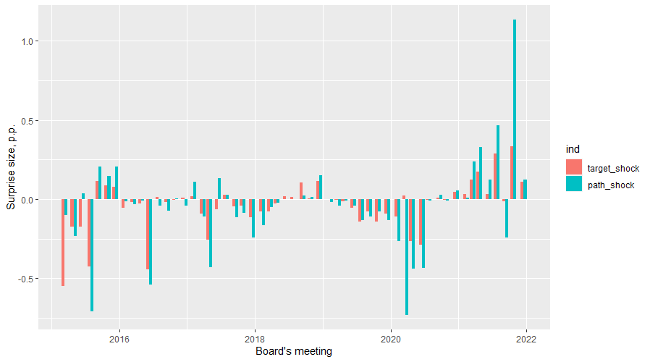
Taking into account the observations made and the approaches available in the literature to assess the role of communication in the emergence of surprises (which are discussed in the relevant sections below), we form the following hypotheses about the emergence of Bank of Russia monetary policy surprises:
(1) The high role of uncertainty/information shocks. In this hypothesis, we consider whether information shocks and macroeconomic and financial uncertainty have an impact on the emergence of monetary policy surprises. It can be assumed that in the context of high uncertainty and frequent information shocks, it is more difficult for the central bank to conduct timely analysis and communicate its vision of the changing situation to the market. This hypothesis is tested in Section 2.
(2) Miscommunication. The central bank may place incorrect emphasis on its communication, which leads to market errors in reading information which is critical for forecasting decisions. In this case, there are narrative gaps between the analysis of the situation by analysts and the rationale for the central bank’s decision. Analysis of this topic can be found in Section 3.
(3) ‘Secret knowledge’ or the central bank’s information channel. This is an assumption that the central bank may possess certain additional non-public economic data or models that the market does not have and therefore cannot correctly predict the decision. This topic is discussed in Section 4.

2. The hypothesis of the high role of uncertainty and information shocks
One of the most popular and intuitive explanations for unpredictable decisions is increased macroeconomic and/or financial uncertainty. When the situation is difficult to predict and is characterised by an increased number of information shocks, it is more difficult for the central bank to make decisions, as well as to explain to the market its vision of the changing situation.
As Conway (2000) observes, while inflation-targeting central banks have done much to create a transparent system of operation for monetary policy, the uncertainty of the environment in which inflation has to be managed has grown alongside this process. This uncertainty comes from different angles: central banks can never be completely certain of the structure and state of the economy, while statistical information often presents surprises. In addition, unexpected events occur from time to time, and the future is inherently unpredictable. Bloom (2009) shows that strong uncertainty shocks pose a serious challenge to macroeconomic authorities, including central banks. The efficiency of monetary and fiscal policies is significantly reduced during uncertainty shocks. Poole and Rasche (2003) also observe that the central bank, as well as the real sector, may occasionally face situations of heightened uncertainty. If the regulator has no influence on these events, it must strive by all means to reduce the uncertainty of its future decisions. The same conclusion is reached by Mendes et al. (2017) after an analysis of the experience of the Bank of Canada. Blattner et al. (2008) point in this regard to the need to improve central bank communication, which takes on unprecedented importance in an environment of high uncertainty.
High uncertainty as a factor of monetary policy surprises (primarily in terms of external risks) has also been pointed out by representatives of the Bank of Russia in an interview. Under these conditions, the central bankers advised the market not to wait for signals from the regulator, but to independently analyse the rapidly changing situation and proceed directly from the logic of key rate decision-making.
Methods for measuring the level of uncertainty and information shocks are developed in several works. The most popular techniques are those proposed by Bachmann, Elstner, and Sims (2013), Jurado, Ludvigson, and Ng (2015), Rossi and Sekhposyan (2016), and Baker, Bloom, and Davis (2016). These methods have been improved in later works. The approach of Bachmann, Elstner, and Sims (2013) is to measure the variance of estimates of the economic situation. Rossi and Sekhposyan (2016) propose the use of an index based on the determination of errors in real GDP forecast relative to the sample distribution of errors in forecasts of the same variable. Jurado, Ludvigson, and Ng (2015), as well as several other researchers, estimate uncertainty by calculating the conditional volatility of forecast errors for a large number of U.S. macroeconomic indicators. Finally, Baker, Bloom, and Davis (2016) apply modern methods of textual analysis. They evaluate a news index of economic policy uncertainty, which reflects the frequency with which words such as ‘economy’ and ‘uncertainty’ are used together in reports in leading media. The experience of applying this approach for Russia was implemented as part of the Index of Global Economic Policy Uncertainty in 2016 by a group of researchers from the University of Chicago and Stanford University. We use it as the base model for our own news index, which is described below.
There are also operational indicators of uncertainty for financial markets. The most famous of these is the VIX, the so-called ‘fear index,’ calculated by the Chicago Option Exchange. It represents market expectations of the 30-day future volatility of the US stock market for the S&P 500 Index. The Russian analogue of this index is the RVI for the RTS market, which has been calculated by the Moscow Exchange since the end of 2013. The principle of its calculation is based on the volatility of actual RTS option prices. In the calculation of the RVI, the nearest and following options with terms to expiration of more than 30 days are used.
Given the research experience described and the data available for Russia, we consider the following models for estimating uncertainty and information shocks:
- for macroeconomic uncertainty – an estimate based on the variance of Bloomberg analysts’ forecast estimates for key macro variables (Model 1):
S₁ = α + β₀*GDP + β₁*π + β₂*P + β₃*I + β₄*Un + β₅*Sl + ε, where (2)
S₁ – surprise value (for analysts – Bloomberg data; for the money market – target shock and path shock)
GDP – variance of analysts’ forecasts of GDP
π – variance of analysts’ forecasts of inflation
P – variance of analysts’ forecasts of industrial production
I – variance of analysts’ forecasts of real wages
Un – variance of analysts’ forecasts of unemployment rate
Sl – variance of analysts’ forecasts of real retail sales
α, β_{0,} β_{1,} β_{2,} β_{3,} β_{4,} β₅, – coefficients
ε – error term
2.) for information shocks – News index based on textual analysis tools (Model 2).
To build the news index, we use the Russian news database described in our work Karpov and Evstigneeva (2022 forthcoming). For the assessment, we use economic news from January 2014 to December 2021, a total of about 1.47 million news items. This database contains 28 major Russian media resources, while the Index of Global Economic Policy Uncertainty (which we use as a base model) includes only the newspaper Kommersant.
To extract the level of uncertainty from the news base, uncertainty topic tokens are used (for more information, see Section 3). The news uncertainty index for a specific month is calculated as the ratio of the number of articles containing uncertainty tokens to the total number of articles in the given month.
We verify the validity of the news index obtained using the Pearson correlation coefficient with the Moscow Exchange RVI. It is 0.5457, versus 0.2807 for the Index of Global Economic Policy. So our index is a better reflection of financial market volatility.
Figure 5. Moscow Exchange RVI (left) and News Uncertainty Index (right)

Figure 6. Moscow Exchange RVI (right) and Index of Global Economic Policy (left)

To test the possible impact of the information shocks measured by our News Uncertainty Index, we consider the following model:
S₁ = α + β* NUI + ε, where (3)
S₁ – surprise value (for analysts – Bloomberg surprises, or, for the money market – target shock and path shock)
NUI – value equal to the value of the News Uncertainty Index in the month of a key rate decision
α, β – coefficients
ε – error term
The series of independent variables are preliminarily cleaned of outliers and checked for normal distributions (Shapiro-Wilk test). After that, the models meet the conditions for using the least squares (LS) method (Gauss-Markov theorem).
Having evaluated the models obtained (the technical results are presented in Annex 3), we come to the following results:
1.) At the 5% significance level, the hypothesis that high variance of professional analysts’ inflation forecasts is associated with the occurrence of monetary policy surprises for professional analysts is not rejected. Thus, in a situation of increased uncertainty of price dynamics, analysts really do find it more difficult to correctly predict the Bank of Russia’s decisions. At the same time, no other variables (variance of forecasts of GDP, industrial production, real wages, unemployment rate and real retail sales) are significant for the emergence of monetary policy surprises. We conclude that macroeconomic uncertainty regarding inflation may make it difficult for analysts to predict the decision.
2.) The second model, which tests the effect of information shocks on surprises as measured by the news index, supports, at the 10% significance level, the hypothesis that monetary policy decisions are even somewhat more predictable in the presence of a large number of information shocks. (Statistically significant coefficients – with negative signs). That is, the market understands and predicts the actions of the central bank a little better during turbulence and information-rich backgrounds than during calmer periods.
This contradictory finding that key rate decisions are slightly more predictable in turbulent conditions can be explained by the Bank of Russia’s more active and transparent communication during such periods. In the initial stage of inflation targeting in Russia (2015–2021), there were many episodes of increased volatility (falling oil prices, sanctions, geopolitical risks, weakening of the ruble, etc.), during which the Bank of Russia had to explain in detail the principles of its response to extraordinary events.
However, this explanation may be criticised. In the early stage of inflation targeting in 2015–2021, the Bank of Russia expanded its communication tools gradually, and such important decisions as holding press conferences after each decision, publishing the trajectory of the key rate, and the section of the website about the model apparatus fell late in the period, in 2021–2021. Until then, communication was limited to press releases on the key rate and the Monetary Policy Report, which, according to the criteria of Dincer and Eichengreen (2014) and Al-Mashat et al. (2018), is clearly not enough to consider communication transparent.
To answer this question for sure, we build another model that estimates the impact of verbal interventions by Bank of Russia representatives before the week of silence (that is, the window of 2–3 weeks before key rate decisions) on the emergence of surprises. Thus, we test the hypothesis of whether more active communication by the Bank of Russia in the run-up to a decision has an effect on the predictability of decisions.
The impact of verbal interventions by Bank of Russia representatives on various indicators of financial markets has been considered in a number of works: Kuznetsova and Ulyanova (2016; 2018), Merzlyakov and Khabibullin (2017), and Zhemkov and Kuznetsova (2017).
Following the logic of the works listed, verbal interventions are understood as verbal statements by representatives of the Bank of Russia which contain hints about a future key rate decision. In this, we take into account all possible forms of interventions: press scrums, press conferences, interviews, speeches at public events, articles, and columns.
As speakers, we select those who most frequently comment on monetary policy on behalf of the Bank of Russia: E.S. Nabiullina (Governor of the Bank of Russia), A.Yu. Simanovsky (Advisor to the Governor of the Bank of Russia), K.V. Yudaeva (First Deputy Governor of the Bank of Russia), S.A. Shvetsov (First Deputy Governor of the Bank of Russia), D.V. Tulin (First Deputy Governor of the Bank of Russia), I.A. Dmitriev (Director of the Monetary Policy Department of the Bank of Russia until June 2018), A.B. Zabotkin (Director of the Monetary Policy Department, Deputy Governor of the Bank of Russia since June 2020), and K.V. Tremasov (Director of the Monetary Policy Department since June 2020).
A list of interventions grouped according to decision, as well as examples thereof, is provided in Annex 4. We take verbal interventions as a factor variable which takes a value of 1 if interventions are carried out and 0 if they are not.
To assess the following relationship, we use the probit model:
S₂ = α + β*IN + ε, where (4)
S₂ – a factor variable for surprises for professional analysts which takes a value of 1 if the proportion of correctly predicted decisions is <50% and 0 if otherwise
IN – a factor variable for interventions
α, β – coefficients
ε – error term
Based on the results of the evaluation (Table 1; the Likelihood Ratio test and the Wald test are used to verify the statistical significance and quality of the model), we find that verbal interventions are associated, at the 10% significance level, with the occurrence of monetary policy surprises – that is, verbal interventions before a decision correspond to lower predictability of the subsequent decision. Thus, we reject the hypothesis that the slightly higher predictability of decisions during periods of increased volatility is associated with active explanatory communication before a decision. This is consistent with the findings in the work of Hwang, Lustenberger, and Rossi (2021). It proves that intensive communication, as measured by the number of speeches from central bankers, worsens the impact of the central bank. Too much communication can be dangerous because of ‘noise pollution’ of the information space and the growing cost of processing the increased amount of information from the central bank.
At the same time, it should be noted that in 2021 (see Figure 7), verbal interventions worked properly: in all cases (at the time of writing, six meetings had been held), decisions were more predictable in the presence of preliminary interventions. This can serve as another confirmation of the initial stage of the formation of communication tools by the Bank of Russia. It takes a significant amount of time for the market to learn to correctly understand the signals of the regulator.
Table 1. Assessment of the impact of verbal interventions before a decision on the emergence of Bank of Russia monetary policy surprises
 | Dependent variable:
 | Surprises
Interventions1 | 0.599*
 | (0.351)
Constant | -0.168
 | (0.230)
Observations | 56
Log Likelihood | -35.803
Akaike Inf. Crit. | 75.607
Note: | *p<0.1; **p<0.05; ***p<0.01

Figure 7. Monetary policy surprises and verbal interventions
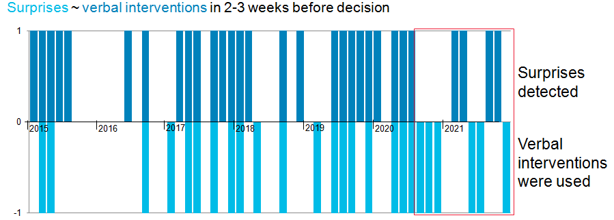

3. Miscommunication hypothesis
In this section, we test the assumption that monetary policy surprises may be based on differing assessments of the economic situation by the central bank and by analysts. For example, if the central bank attaches particular importance to a particular factor, while analysts do not, this may cause that factor to be underestimated by the market and, accordingly, contribute to the emergence of an unexpected decision. We are particularly interested in situations where the central bank systematically overestimates or underestimates certain factors in comparison with the market. This situation can lead to sustained miscommunication and a shift in its focus.
We know of only one example of similar work in the scientific literature. Ter Ellen et al. (2019), using a textual analysis method based on Latent Semantic Indexing (LSI) with a teacher, evaluate central bank narrative surprises to the media using the experience of Norges Bank as a case study. They come to the conclusion that, although a strong link between narrative communication gaps and monetary policy surprises has not been identified, narrative assessment can provide the central bank with important additional information about the quality of communication and its focus. In addition, narrative gaps significantly affect the media’s interest in the topic of rate decisions.
Additionally, we rely on the techniques described by Luangaram and Wongwachara (2016). In this work, key communication topics are modelled for 12 inflation-targeting central banks. For this purpose, Luangaram and Wongwachara use one of the most popular methods of thematic modelling today: Latent Dirichlet allocation (LDA). The possibilities of using textual analysis tools for central banks are described in more detail in a review by Bholat et al. (2015).
Based on these works, we have developed the following algorithm for modelling narrative gaps:

Figure 8. ‘Conveyor’ of narrative gap modelling
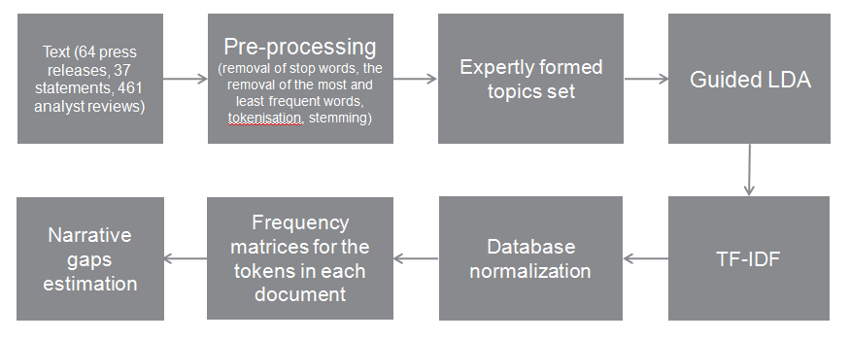
For modelling, we collected the following datasets: on the one hand, press releases and statements from the Governor after the Bank of Russia Board of Directors’ meetings on monetary policy, and on the other hand, reviews of professional analysts with forecasts of Bank of Russia decisions. The data cover the period from February 2014 to September 2021. The corpus contains a total of 64 press releases, 37 statements, and 461 analyst reviews. Since analyst reviews are available mainly in English, and the Bank of Russia’s communication on the key rate is officially translated, we use English as the working language of the study.
Having collected the data, we carry out standard pre-processing, which includes the removal of stop words, the removal of the most and least frequent words, and tokenisation (splitting the text into individual elements); then, we perform stemming (that is, we replace words with their ‘root’ bases, for example, inflation → inflat). This allows the concentration of words with common roots.
Then it is necessary to highlight the topics. Since we have a small dataset, which is not enough for machine learning algorithms to work fully without a teacher, we combine two techniques: guided LDA and a dictionary-based approach. At the same time, our initial definition of topics, as in ter Ellen et al (2019), is made subjectively based on the Bank of Russia’s allocation of decision factors and the configuration of the extended Taylor rule for a small open economy with inflation targeting (Gali and Monacelli, 2005; Svensson, 2010). We also take into account the long periods of increased volatility in the Bank of Russia’s inflation targeting experience and the coronavirus crisis that began in 2020. Thus, the following topics are expertly formed:
(1) Inflation
(2) Inflation expectations
(3) Economy
(4) Volatility
(5) Monetary conditions
(6) Government (fiscal policy and other government measures)
(7) Covid-19

To primarily identify the set of tags for each of the topics, we apply Guided LDA to the entire corpus. This technique extends the classical LDA of Blei et al. (2003) and Pritchard et al. (2000), which is based on the simple idea that the probability of associating a text with a certain topic is related to the frequency of certain words in it. That is, the word ‘ball’ is more easily found in the topic ‘sport’ than in the topic ‘medicine’. LDA is a hierarchical Bayesian model in which a multinomial variable with a Dirichlet a priori distribution is responsible for the distribution of topics. LDA is used mainly as a method for the thematic modelling of large sets of texts without a teacher, where it shows the best results. Guided LDA is an attempt to apply LDA to small corpora of texts by applying a teacher-assisted training algorithm. The method is described and applied by Toubia et al. (2014). There is also a similar variation of the method called Labelled LDA (Ramage, 2009). The key advantage of these innovations is the ability to control the LDA algorithm, primarily through a predefined set of tags incorporated into the model. At the same time, the output of the model is also a probabilistic structure of the words in the topic. The expert set of key tags passed into the model guide it, but do not determine the results. In this, the probability of the appearance in topics of service words that are common to a variety of topics is quite high. Having obtained the set of words that identify a topic, we clear it of the service parts of speech and the words with the highest and lowest frequencies, thus increasing the concentration of the semantic part of the topic, as well as connecting related topics (for example, those related to the acceleration and deceleration of inflation. In our study, these are all included in a single, more general topic: ‘Inflation’). As a result, we obtain the following set of topic-identifying tokens:

Table 2 . Topic-identifying words
# | Topic | Tags
Topic 0 | Inflation | ‘inflat’, ‘consum’, ‘price’, ‘acceler’, ‘season’, ‘annual’, ‘proinflationari’, ‘disinflationari’, ‘factor’, ‘slow’, ‘pressur’, ‘overheat’, ‘cost’, ‘inflationari’, ‘spiral’, ‘product’, ‘servic’, ‘basket’
Topic 1 | Volatility | ‘foreign’, ‘geopolit’, ‘volatil’, ‘extern’, ‘risk’, ‘global’, ‘shock’, ‘oil’, ‘currenc’, ‘dollar’, ‘barrel’, ‘opec’, ‘sanction’, ‘sovereign’, ‘harvest’, ‘commod’, ‘world’, ‘concern’, ‘uncertainti’
Topic 2 | Economy | ‘econom’, ‘economi’, ‘growth’, ‘dynam’, ‘compani’, ‘recoveri’, ‘recov’, ‘demand’, ‘invest’, ‘product’, ‘import’, ‘export’, ‘sector’, ‘suppli’, ‘develop’, ‘aggreg’, ‘weaken’, ‘busi’, ‘unemploy’, ‘labour’
Topic 3 | Monetary conditions | ‘rate’, ‘pace’, ‘yield’, ‘ofz’, ‘monetari’, ‘condit’, ‘deposit’,’save’, ‘debt’, ‘mortgag’, ‘loan’, ‘financi’
Topic 4 | Inflation expectations | ‘household’, ‘inflat’, ‘expect’, ‘peopl’, ‘citizen’, ‘famili’, ‘unanchor’, ‘elev’, ‘consum’, ‘activ’, ‘food’, ‘petrol’, ‘incom’
Topic 5 | Government | ‘govern’, ‘budget’, ‘fiscal’, ‘rule’, ‘tax’, ‘infrastructur’
Topic 6 | Covid-19 | ‘pandem’, ‘coronavirus’, ‘vaccin’, ‘lockdown’, ‘epidem’

Next, we compile frequency matrices for the tokens in each document (press releases and statements or analyst reviews on a particular decision), normalise them by median (because we are dealing with exponential frequency distributions), and estimate the difference in weight of each of the seven topics in Bank of Russia communications and in economic analyst reviews from before the decisions. The results of these narrative gaps by topic are presented in Figures 9–15, and the general picture is presented in Figure 16.
Based on the data obtained, we make the following observations:
1.) The narrative gaps in Bank of Russia communications are substantial. However, they can be associated with different views on the situation in the economy compared to those of analysts, and they are largely determined by the specifics of the Bank of Russia’s materials. In particular, they can be associated with the template structure of Bank of Russia materials. For example, in the press release on the key rate, there is always a paragraph on the economy. Analyst reviews are more situational and context-specific. This may explain the significant gaps in the ‘Economy’ topic.
2.) The narrative gaps in the ‘Inflation’ and ‘Inflation expectations’ topics are strongly correlated by both the Bank of Russia and analysts. That is, both analysts and the Bank of Russia interpret these topics in close connection. Moreover, the correlation of these topics in later periods even increases. The significant gaps in the coverage of these topics between April 2016 and July 2017 can probably be explained by analysts’ lesser interest in these topics during the period of deceleration of inflation/reduction of inflation expectations. It is important to note that, while before 2020, the Bank of Russia steadily attached more importance to inflation expectations in its communication than analysts did, analysts later began to pay much more attention to these indicators. It can even be said that analysts rely almost exclusively on these two indicators when forecasting a decision. At the same time, this change in trend can be explained in part by the effects of the corpus: only 4 governor’s statements are included each year until 2020, but after that there are already 8. Yet, it is more likely that this is mainly due to the adjustment of the market to the Bank of Russia’s mandate to ensure price stability. Since 2020, analysts have been ‘fixated’ on the topics of inflation and inflation expectations, and it is more difficult for the Bank of Russia to communicate other decision factors. On average for the period under review, the gaps in the ‘Inflation’ topics are positive (i.e., the Bank of Russia attaches more importance to the topic), and they are negative for the ‘Inflation expectations’ topic (i.e., analysts attribute more importance to the topic).
3.) It is noteworthy that the Bank of Russia assesses the risks associated with the coronavirus significantly higher than analysts (except for in the very beginning of the pandemic, when analysts still responded faster and showed greater concern).
4.) The biggest positive gap is in the averages on the ‘Monetary conditions’ topic, while the largest negative gap is on the ‘Inflation expectations’ topic.

Figures 9–15. Narrative gaps in Bank of Russia communications
(coloured lines – Bank of Russia; grey lines – analysts)

Frequency of ‘Inflation’ terms Frequency of ‘Inflation expectations’ terms
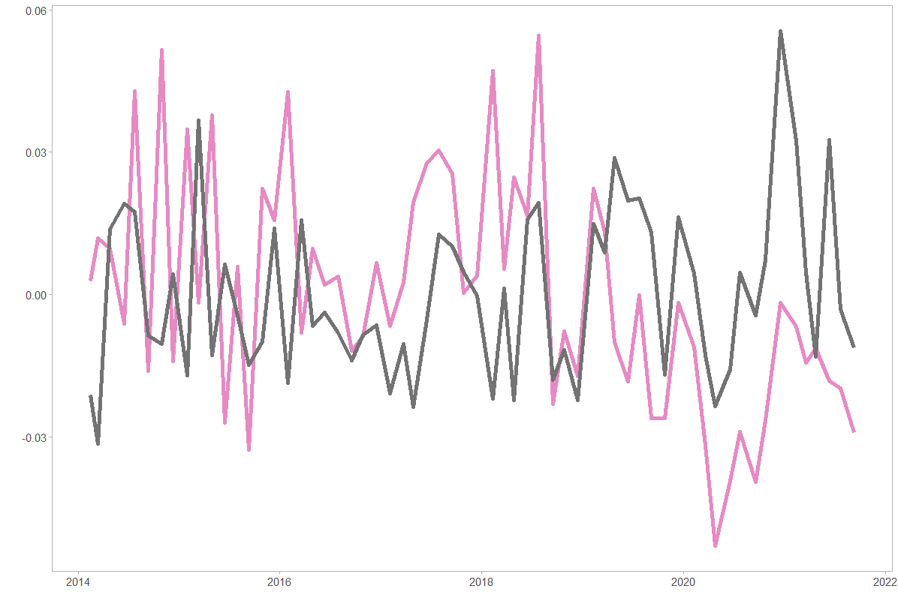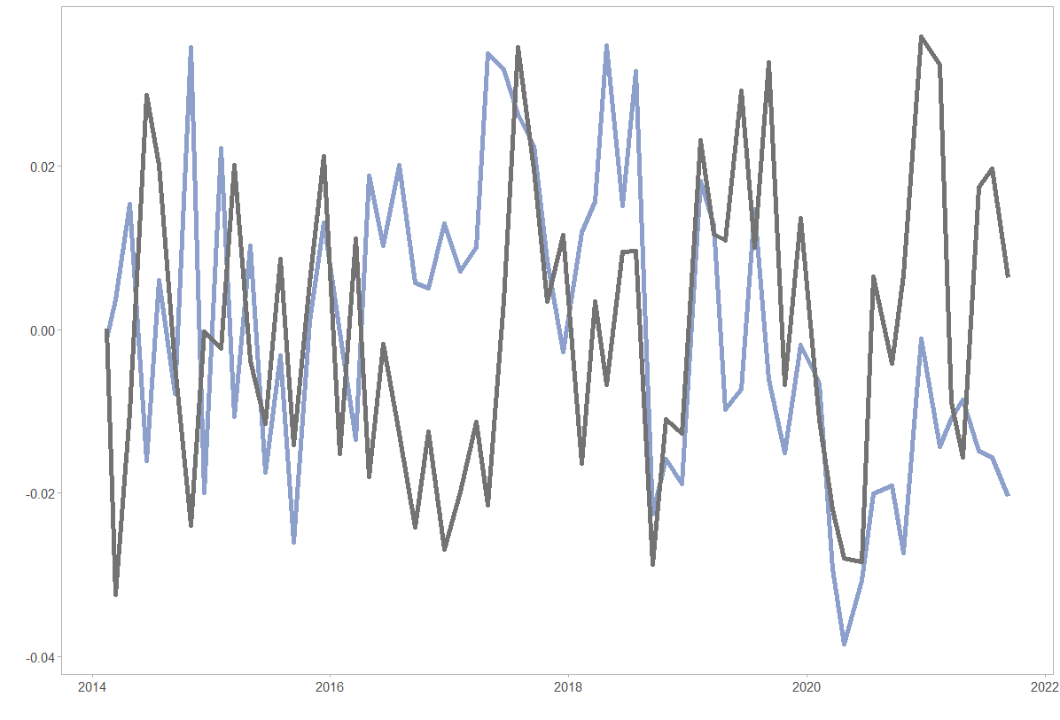

Frequency of ‘Volatility’ terms Frequency of ‘Covid-19’ terms

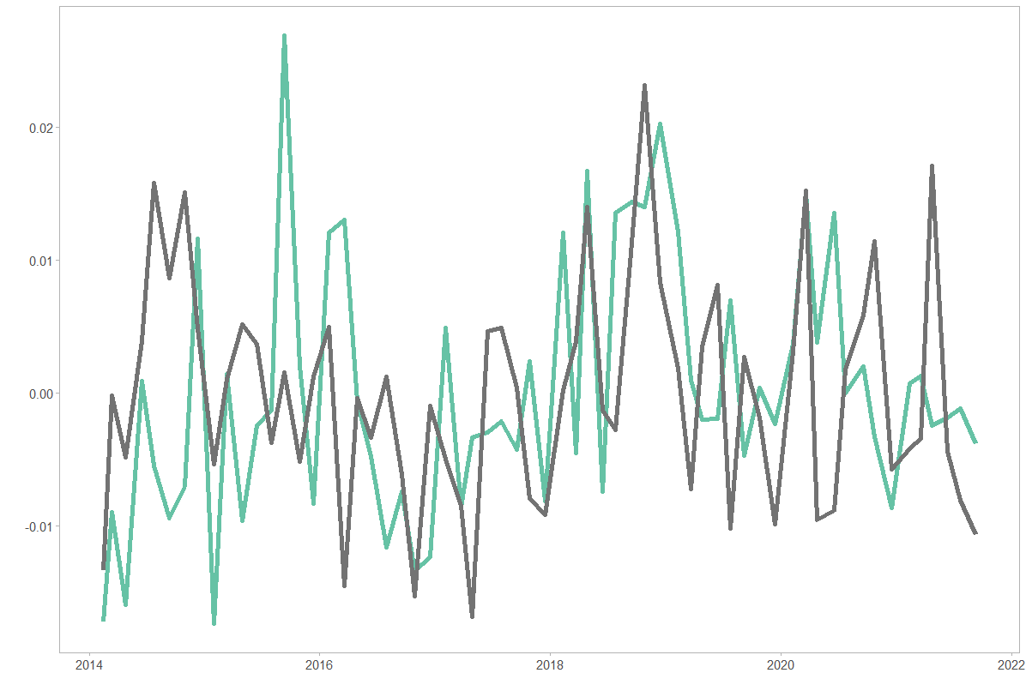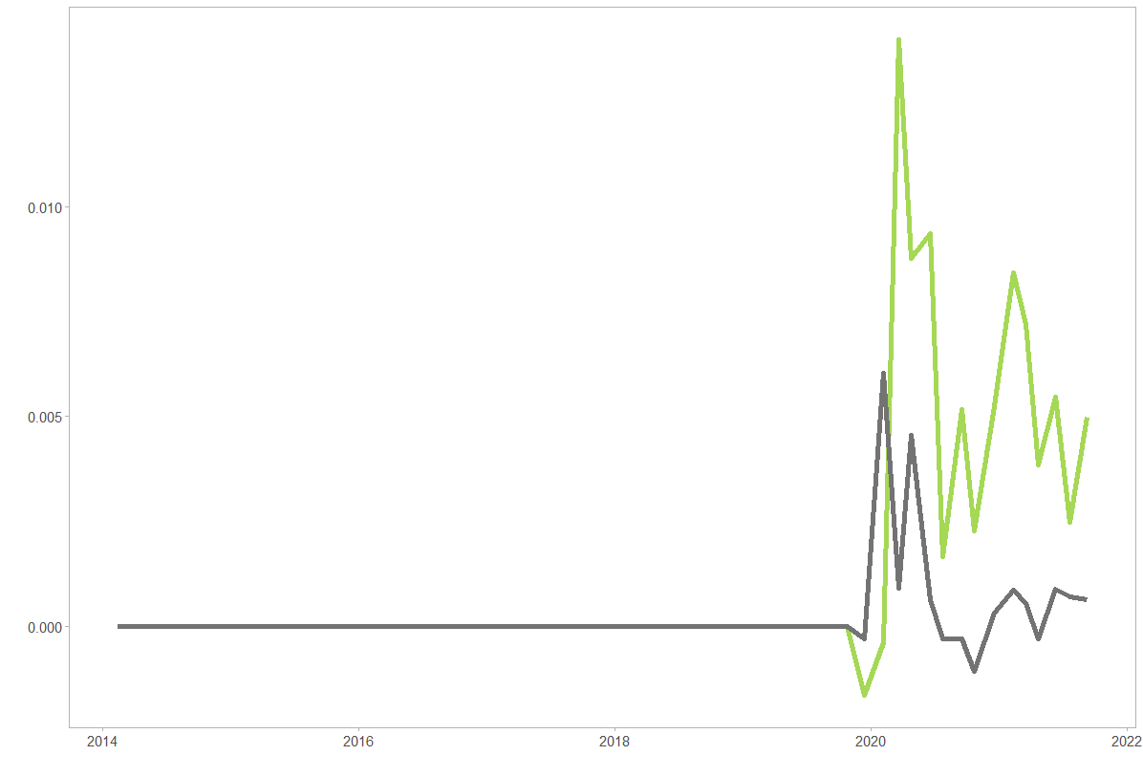

Frequency of ‘Economy’ terms Frequency of ‘Monetary conditions’ terms
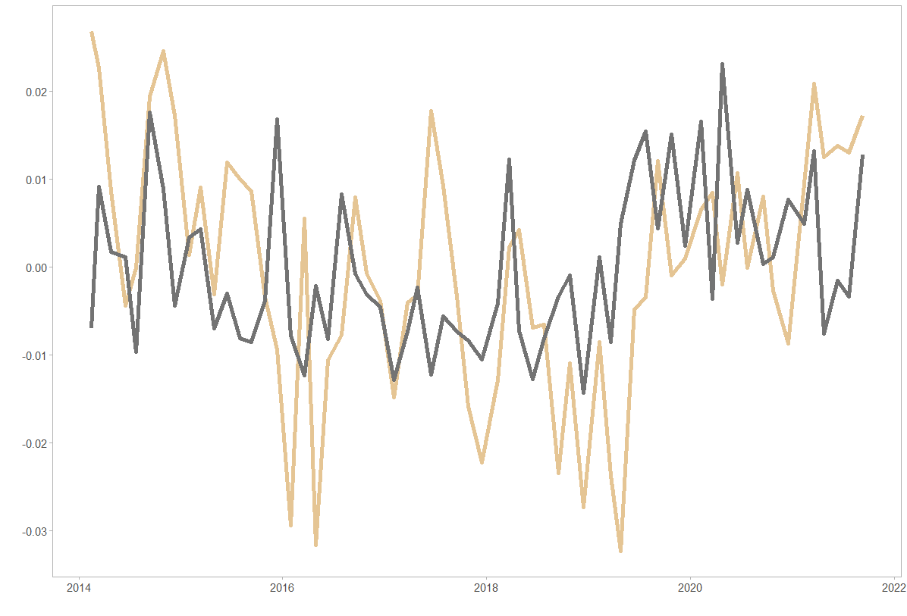 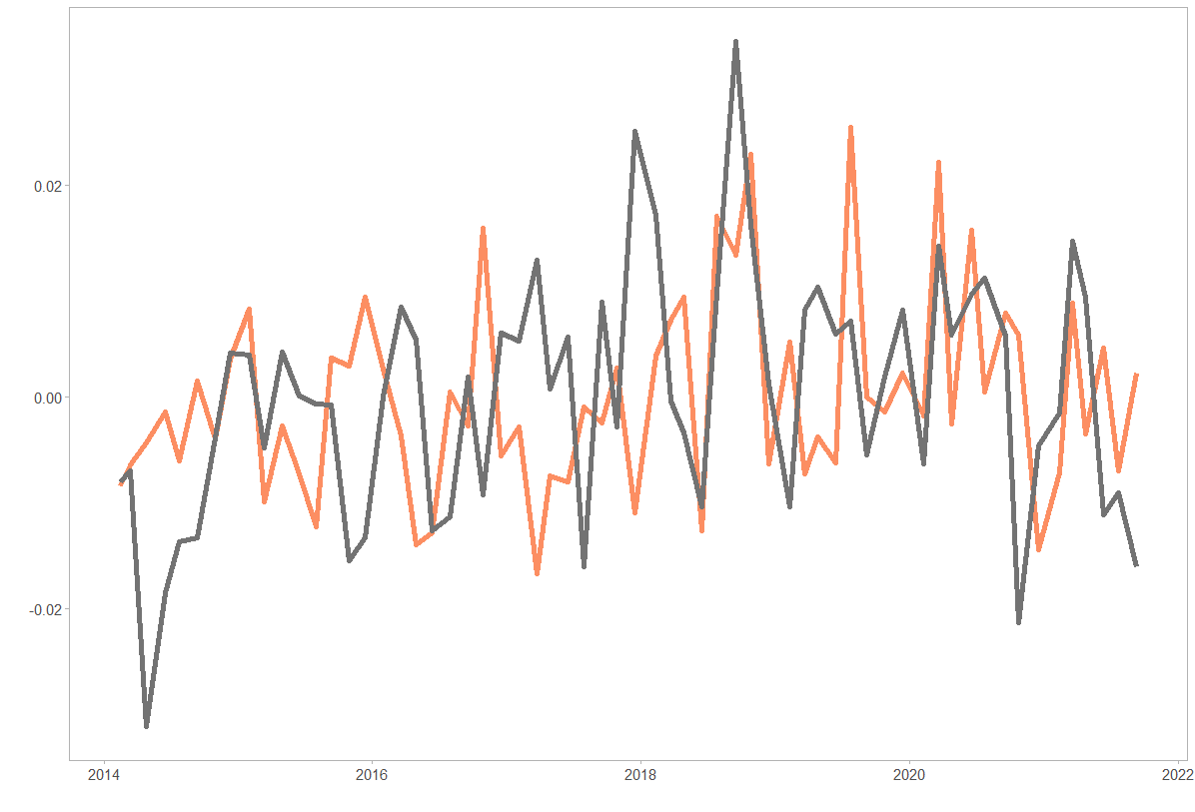 Frequency of ‘Government’ terms

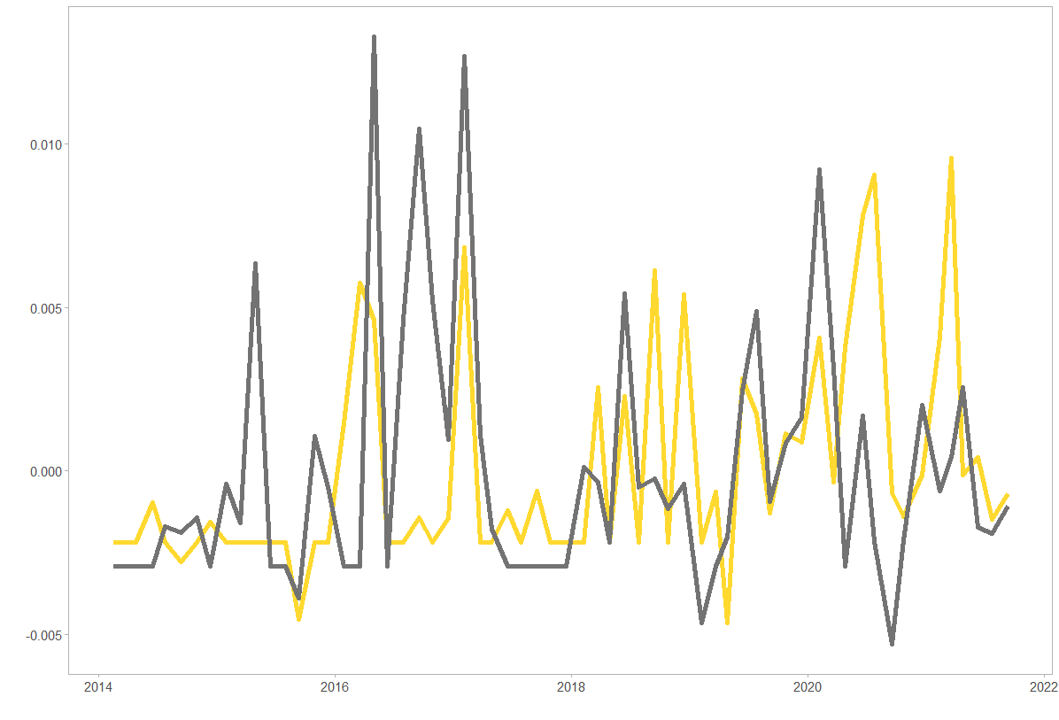

Figure 16. Narrative gaps in Bank of Russia communications and analysts’ assessments of the situation
(upward deviation from zero on the Y-axis – the Central Bank attaches more importance to the factor than analysts; downward deviation from zero on the Y-axis – analysts attribute more importance to the factor than the Central Bank)
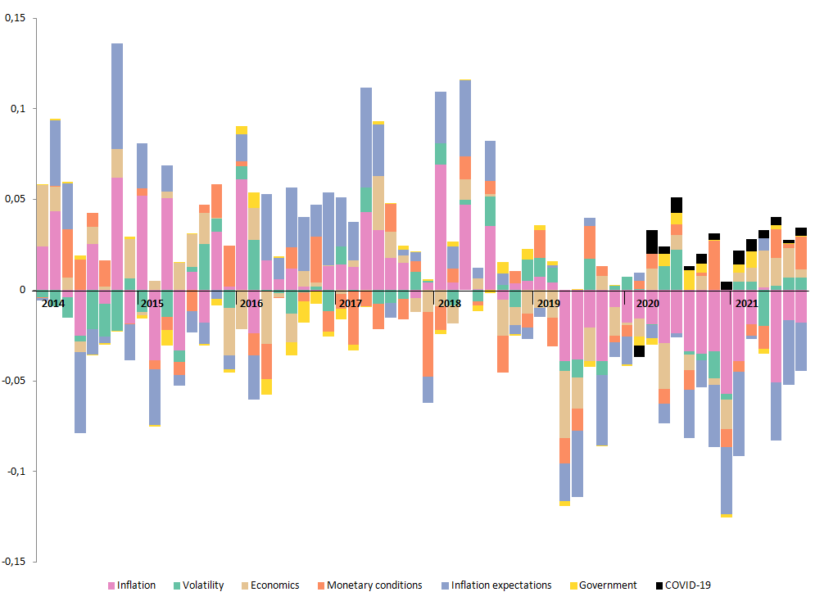

To assess the possible relationship between narrative gaps and monetary policy surprises, we perform a regression analysis:
S_{3,t} = α + β*nd_{t} + ε, where (6)
S_{3,t} – classically measured normalised monetary policy surprises at date t
nd_{t} – narrative gaps at date t (analyst reviews before the decision and the Bank of Russia decision itself)
α, β – coefficients
ε – error term
As nd_{t}, both each of the types of gaps separately and their entirety throughout the sum of the modules are considered.
Judging by the results of the regression analysis, narrative gaps may explain a very modest part of the surprises. This is in line with the results obtained by ter Ellen et al. (2019). Narrative gaps in inflation and volatility are most important in predicting surprises (5% significance; see Table 3). From this, we can conclude that monetary policy surprises are probably not based on different assessments of the economic situation by the central bank and analysts, although assessments of inflation and volatility do make a (very limited, but statistically significant) contribution.
Table 3. Assessment of the influence of narrative gaps in terms of inflation and volatility on the occurrence of surprises in Bank of Russia monetary policy
 | Dependent variable:
 | Unpredictability
Infl_diff_corr | 294.414**
 | (146.774)
Constant | 35.005***
 | (4.158)
Observations | 61
R² | 0.064
Adjusted R² | 0.048
Residual Std. Error | 32.452 (df = 59)
F Statistic | 4.024** (df = 1; 59)
Note: | *p<0.1; **p<0.05; ***p<0.01

 | Dependent variable:
 | Unpredictability
Volatil_diff_corr | -760.077**
 | (377.891)
Constant | 34.354***
 | (4.100)
Observations | 62
R² | 0.063
Adjusted R² | 0.048
Residual Std. Error | 32.285 (df = 60)
F Statistic | 4.046** (df = 1; 60)
Note: | *p<0.1; **p<0.05; ***p<0.01

4. The hypothesis of the central bank’s ‘secret knowledge’
One of the reasons for occurrence of monetary policy surprises investigated in the literature is related to the information being transmitted. Market participants receive certain additional information on the central bank’s assessment of the economic situation from monetary policy decisions and their communication (Hoesch, Rossi, and Sekhposyan, 2020). New information influences the correction of their expectations and forecasts.
The key assumption is the hypothesis of information advantage or the ‘secret knowledge’ of the central bank. It is assumed that this advantage allows the central bank to better forecast macroeconomic indicators and assess the situation in the economy. The existence of this ‘secret knowledge’ may be solely the belief of the market, or it may be an objective advantage of the central bank in terms of analysis and forecasting.
In the case that the central bank has a proven information advantage, it is possible to draw conclusions about communication gaps in terms of decision-making logic and the analytical and instrumental apparatus. In a pronounced situation of informational advantage of the central bank, the market does not try to predict decisions based on publicly available information about the state of the economy, but waits for new inputs from the central bank on the economic situation, which appear along with its monetary policy decision. A situation of informational advantage is characterised by counterintuitive market behaviour: when the central bank raises the rate, the market does not lower its inflation forecasts, counting on the effectiveness of the regulator in achieving the goal of price stability, but rather increases them, thinking that the actions of the regulator are related to an upward revaluation of inflation forecasts. When the central bank is as open as possible in terms of publishing its model and analytical apparatus, the information channel comes to naught. This is proven for the US Federal Reserve by Hoesch, Rossi, and Sekhposyan (2020). These authors directly link the disappearance of the Federal Reserve’s information advantage to the development of communication.
Several research articles have been devoted to testing the presence of an information advantage at central banks and assessing the reaction of analysts’ forecasts to monetary policy decisions. In particular, Romer and Romer (2000) examine the US Federal Reserve’s information advantage and the impact of monetary policy decisions on commercial forecasts. Based on the results of the study, the authors conclude that in 1970–1991, the US Federal Reserve had ‘secret knowledge’ in forecasting inflation and GDP at horizons of up to 6 quarters. At the same time, analysts’ inflation forecasts shifted upward as monetary policy tightened.
In the study of central banks’ ‘secret knowledge’, most authors look at the US Federal Reserve, even though their forecasts were previously published with a five-year lag. Hubert (2009) draws attention to this problem. The author investigates the presence and sources of information advantage in five countries (Great Britain, Japan, Sweden, Canada and Switzerland). As a result of the analysis, the author makes a conclusion about the existence of ‘secret knowledge’ only for the Swedish Riksbank from the late 1990s to 2007. The study also showed that during this time period in Britain and Switzerland, analysts’ inflation forecasts for a year or more ahead were more accurate than the central banks’ forecasts. Boero, Smith and Wallis (2008) draw a similar conclusion for Britain using a different source of analyst predictions.
In addition to information asymmetries, Hubert (2009) assesses the impact of the disclosure of central bank forecasts on inflation and GDP forecasting by analysts. This topic is also analysed in works by Morris and Shin (2002), Svensson (2006), and Amador and Weill (2010). In addition, the author analyses the mutual influence of central bank and analyst forecasts.
The work of Romer and Romer (2000) serves as the basis for a later study of information asymmetry in the United States by Hoesch, Rossi, and Sekhposyan (2020). The authors slightly modify the methodology and check how the presence of an information advantage changed over time using the rolling window method on two time intervals (1979–2003 and 2004–2014). The study shows that the Federal Reserve’s ‘secret knowledge’ in forecasting inflation and GDP disappeared on mid-term horizons in the early 1990s, and on short-term horizons in the early 2000s. The information advantage is also estimated by Fair and Shiller (1989; 1990) and Sims (2002).
In assessing the information advantage, the authors of these studies pay attention to the rationality of forecasts in general. Often, the forecasts of macroeconomic indicators become a separate subject of research. Blix, Wadefjord, Wienecke and Adahl (2001) analyse 1990s forecasts of various macro-variables from 250 sources in five countries. The results of the analysis show that it is more difficult to predict economic growth than inflation. At the same time, inflation forecasts are overestimated, and growth forecasts are underestimated. Patton and Timmermann (2012) and Rossi and Sekhposyan (2015) focus on estimating and analysing the rationality of forecasts.
Some authors attribute the existence of a central bank’s ‘secret knowledge’ not to early access to statistical information, but to a more advanced forecasting apparatus (Romer and Romer, 2000; Hubert, 2009). The lack of information advantage or its disappearance is explained by the central banks’ level of transparency and its increase (Hubert, 2009; Hoesch, Rossi, and Sekhposyan, 2020; Laséen, 2020). The more information the central bank discloses, the smaller the difference in the perception of the economic situation between it, the market, and analysts. Consequently, the number of monetary policy surprises is also decreasing.
When testing the hypothesis of the Bank of Russia’s ‘secret knowledge’, we rely on research on information advantage, mainly the classic work of Romer and Romer (2000).
To test the rationality of the forecasts and the hypothesis of the Bank of Russia’s information advantage, we used the Bank of Russia’s year-end inflation forecasts and the Bloomberg consensus from March 2015 to October 2021 (for forecasts for the current year). For forecasts for the next year, the sample is limited to October 2022; for the two-year forecast horizon, the sample is limited to December 2019. This is due to the fact that the evaluation of these regressions requires actual data, which are currently available for 2021 at the latest.
The Bank of Russia presents forecasts of macro indicators on a three-year horizon. However, these are not included in the study, as analyst forecasts for more than two years ahead are not available. In addition, the Bank of Russia publishes forecasts 4 times a year (except for 2019, when 5 forecasts were published), which also serves as a limitation on the sample size. The number of observations for current-year forecasts is 29, for the next year, 25, and for the two-year period, 21. As forecast values, we use point forecasts or the middle of the interval if the forecast was published as a range.
In testing the hypothesis of the existence and rationality of a Bank of Russia informational advantage in predicting inflation, we focus on the dates of the Monetary Policy Report (when the forecast was published as part of it) and the dates of the medium-term forecast from when it began to be published separately the week before the reports were published as part of the press release on the key rate. Analysts’ forecasts were collected for the corresponding dates. Charts of inflation forecasts and errors in the Bank of Russia’s and analysts’ forecasts are given in Annex 5.

4.1. Verification of forecast rationality
Verification of the hypothesis about the rationality of forecasts is required to test our hypotheses of interest about the existence of an information advantage. We proceed from the assumption that it is possible to draw correct conclusions about the presence of an information advantage if the prerequisites of this hypothesis are met (Romer and Romer, 2000).
In testing the hypothesis of the rationality of forecasts and further researching information advantage, we focus only on inflation forecasts. There are several reasons for excluding GDP from the analysis. First, this macroeconomic indicator is more difficult to predict. This has also been proven for other countries by Blix, Wadefjord, Wienecke and Adahl (2001). In addition, Rosstat does not publish the actual GDP value once, but gives several estimates. This may also influence the rationality of the forecasts. Finally, the year 2020 falls into the sample. In 2018–2019, it was impossible to predict the onset of the pandemic. In 2020, due to high uncertainty, it was difficult to assess the scale of the consequences and the pace of economic recovery. This inevitably affects the magnitude of forecast errors. Although, it also pertains to inflation, the influence of the pandemic on it was much milder.
Before testing the hypotheses, we construct scatter diagrams of the Bank of Russia’s and analysts’ inflation forecasts. The charts are given in Annex 6. The diagrams are constructed to include forecasts for December 2014. Since then, the Bank of Russia has been publishing medium-term macroeconomic forecasts as part of the Monetary Policy Report. However, the charts show that these points are clearly outliers. We do not include them in the calculations when testing this hypothesis and the information advantage hypothesis.
For the initial comparison of the forecasts of the Bank of Russia and those of the analysts, we calculate the mean squared errors of the inflation forecasts. The mean squared errors in the Bank of Russia’s inflation forecasts for the end of the current year are much smaller than the errors in the analysts’ forecasts. The errors of forecasts for the next year are similar. For the two-year horizon, the errors of the analysts’ forecasts are slightly lower. A table is provided in Annex 6.
In the following regressions, we include actual and forecast inflation values. We test the following hypothesis:
Rationality of inflation forecasts:
$π= α+{β\hat{π}}_{BR or Analysts} +ε$ (7)
where π – the actual inflation,
${\hat{π}}_{BR or Analysts}$ – inflation forecast of the Bank of Russia or the analysts (Bloomberg consensus).
Inflation forecasts are rational if α = 0 and the coefficient in the inflation forecast is 1. The coefficients in the Bank of Russia forecasts are significant at the horizons of the current year and the two-year period. The significance of the regression is confirmed only when forecasting for the current year. However, when testing this hypothesis, the size of the coefficients is important. Therefore, in addition to evaluating the regressions, we performed an F-test for the double hypothesis that α = 0 and β = 1. The hypothesis cannot be rejected only for forecasts for the current year. For the remaining forecast horizons, the assumption of linear regression about the normal distribution of errors is violated.
The coefficients for the analysts’ forecasts are significant for the same horizons: for the current year and for two years ahead. However, according to the F-test for equality of the coefficient to one and the free term to zero, the hypothesis is rejected for all types of predictions. At the same time, the assumption of a normal distribution of errors has been violated. The results of the regression evaluation and the F-test are also presented in Annex 6.
In order to draw the correct conclusions about the rationality of forecasts, several clarifications must be made. We checked for serial correlation, since, when the facts change, the forecasts can be adaptive and change in the same direction. As a result, the forecast error will be correlated with its previous value. This can affect the estimation of the statistical significance of the coefficients. The test is conducted using the Durbin-Watson criterion. We find a consistent correlation across all time horizons for both forecast sources. In addition to a consistent correlation, we test the data for homoscedasticity using the Breusch-Pagan test. The test shows the existence of the heteroscedasticity of the analysts’ inflation forecasts at all time horizons. Due to the presence of heteroscedasticity and serial correlation, all regressions are estimated taking into account robust standard errors in the Newey-West form.
According to the data obtained, rationality is confirmed for the forecasts of the central bank on horizons of up to three quarters (for the current year).

4.2. Testing the hypothesis of the Bank of Russia’s information advantage
Next, we check the main hypothesis of information advantage in inflation forecasting.
We consider the following regression:
$π= α+β_{1}{\hat{π}}_{BR}+β_{2}{\hat{π}}_{Analysts} +ε$ (8)
where π – the actual inflation,
${\hat{π}}_{BR}$– the Bank of Russia’s inflation forecast,
${\hat{π}}_{Analysts}$ – the analysts’ inflation forecast (Bloomberg consensus).
We assume that the central bank has an informational advantage over analysts if the coefficient in its forecasts is meaningfully different from zero.
The results of the regression evaluation are presented in Annex 7. According to the data obtained, the Bank of Russia has ‘secret knowledge’ or an information advantage in forecasting inflation on horizons of up to three quarters. The coefficient for the Bank of Russia forecasts for the current year is more than one and is statistically significant. However, the results of the regression estimation for the longer forecast horizons led to other conclusions. The existence of an information asymmetry in forecasting inflation for the next year and the two years ahead is not confirmed. At the same time, the assumption of the normal distribution of errors is not fulfilled. The forecast rationality hypothesis is also rejected for these forecast horizons. When testing the hypothesis of information advantage, we find the presence of serial correlation. All regressions are estimated taking into account robust standard errors.
To analyse the information advantage in dynamics and validate the findings, we also evaluate the regressions for the forecasts for the current year and next year using a rolling window method with a size of 16 observations. The evaluation was performed according to the methodology proposed by Hoesch, Rossi, and Sekhposyan (2020). However, the use of this method has several limitations. The small number of observations for the forecast horizons analysed (29 and 25 respectively) does not allow for a larger window size. But its decrease may also affect the correctness of the results. In this case, regressions with fewer than 16 observations will be evaluated for each window.
The rolling window regression evaluation confirms the previous findings. The Bank of Russia had an informational advantage in forecasting inflation over short-term horizons throughout the period under study (2015–2021). A detailed description of the results and charts of the t-statistic values obtained are presented in Annex 7.
On the basis of the information received, we draw the following conclusions:
The Bank of Russia has an information advantage in forecasting inflation in comparison with analysts on horizons of up to three quarters. In other words, the central bank has additional information or tools to predict inflation more accurately.

4.3. Testing the hypothesis of the impact of monetary policy decisions on analysts’ forecasts
The assessment of this hypothesis allows us to understand how the Bank of Russia’s key rate decisions affect analysts’ forecasts in the presence of an information asymmetry. In other words, we investigate whether the Bank of Russia’s information advantage is revealed through its monetary policy decisions.
It is important to note that the data sample is slightly different from that used in the previous block. The regression does not include actual inflation values, allowing for the expansion of the sample to include forecasts for 2022 and 2023. The number of observations for the forecasts for the current and next years is 29 units and 24 units for two years. Slightly different dates are used for the analysts’ forecasts. We take the difference between the analysts’ forecast a week after the Bank of Russia Board of Directors’ meetings on the key rate and the forecast the day before. The dates of the Bank of Russia forecasts are still tied to the dates of the Monetary Policy Report and the publication of the medium-term forecast. Key rate decisions are measured through dummy variables, where -1 is a decision to reduce the rate (mitigation), 1 is a decision to increase the rate (monetary tightening), and 0 is a decision to maintain the rate.
The following regression is evaluated to test the hypothesis:
${∆\hat{π}}_{Analysts}= α+β_{1}Decision+β_{2}{∆\hat{π}}_{BR} +ε$ (9)
where ${∆\hat{π}}_{Analysts}$– the difference between the analysts’ forecasts one week after the key rate decisions and the day before,
${∆\hat{π}}_{BR}$– the difference between the current and previous Bank of Russia inflation forecasts,
Decision – a key rate decision (dummy variable).
Key rate decisions indicate a disclosure of information advantage if the coefficient in the decision is significantly different from zero. For example, if it is greater than zero, then a tightening of monetary policy leads to an increase in analysts’ inflation forecasts.
The results of the regression analysis are provided in Annex 8.
Based on the results, we can draw the following conclusions.
As the key rate rises, analysts’ inflation forecasts do shift upward, although the impact is rather limited. This applies to inflation forecasts for the current year and the next year – the coefficients differ significantly from zero. This conclusion is not confirmed at the two-year forecasting horizon. This probably indicates analysts’ high confidence that the Bank of Russia will return inflation to the target on the medium-term horizon. However, a conclusion about the possible impact of information asymmetry on upward adjustments of forecasts can only be drawn for short-term forecasts. This is due to the fact that the existence of an information advantage is confirmed only for this forecasting horizon and the assumption of the normal distribution of residuals for the next year forecasts is not fulfilled.
Based on these findings, we can conclude that the Bank of Russia, in the opinion of the market, has a significant information advantage in terms of forecasting and estimating inflation. To reduce the unpredictability of decisions, the Bank of Russia should disclose in its communication many more details of its model and analytical apparatus, to which the market currently has no access.

5. Policy recommendations
We recorded the evolution of communication between the Bank of Russia and the market over this period.
In the early years of the period (2015–2019), the low predictability of surprises was determined by insufficient communication of the economic situation (namely, in terms of inflation) and an unsatisfactory system of communication signals. The market did not correctly understand the verbal interventions before decisions. In many cases, they worked the other way around, i.e., the signals did not help, but instead prevented the market from expecting the right decision.
In 2019–2021, the situation changed noticeably. First, the market understood the mandate to ensure price stability and focused on forecasting decisions on inflation and inflation expectations (hypothesis testing and miscommunication data). Analysts rely less on other decision factors. Second, the market began to correctly interpret the signals before decisions from about the second half of 2020. Third, analysts’ needs for the disclosure of information on the analytical and forecasting apparatus have significantly increased and are not yet met. The market does not fully understand how the Bank of Russia weighs the inflation picture when making decisions, which is evidenced by the model’s conclusions about informational advantage.
Based on this study, we can make the following recommendations to the Bank of Russia to increase the predictability of monetary policy decisions in terms of developing communication as a tool:
1.) The conditions for using Forward guidance elements are in place: the market perceives signals correctly before decisions are made.
2.) There is a need for a substantial increase in transparency in communication with the market concerning the analytical and forecasting model apparatus, the decomposition of inflation forecast revisions, and more thorough and accurate communication on the role of inflation in decision-making. The market does not fully understand how the Bank of Russia weighs the inflation picture when making decisions (all the steps are given by Al-Mashat et al. (2018)). The information demands of analysts for such information is huge (conclusions of the model about miscommunication) and not satisfied.
3.) It is necessary to reduce the formulaic nature of key rate communication materials to narrow the narrative gaps in favour of a situational framework. This will allow for clearer communication of the current economic situation and the weight of the individual arguments in the decision and will allow the right emphasis to be placed.

6. Conclusions
In this study, we have provided a systematic view of the role of communication in the emergence of monetary policy surprises.
To this end, we first assessed the current level of predictability of decisions separately for professional analysts and for the money market. In the 2015–2021 period, on average, 32.9% of analysts in the Bloomberg survey could not correctly predict the Bank of Russia’s key rate decisions. This figure corresponds to similar data for banks in developing countries at a comparable stage of inflation targeting. To analyse the role of communication in the emergence of financial market surprises, we divided monetary policy surprises for the financial market into surprises about the decision directly taken (target shock) and surprises about the future trajectory of the key rate (path shock), which take more account of communication. To identify surprises for the financial market, the method of high-frequency identification was used. It should be noted that the Bank of Russia was slightly more predictable for the financial market than for analysts during the period under review: there were only 11 considerable surprises for the market, but 14 for the analysts.
Taking into account the available literature on the analysis of monetary policy surprises and its observations, we formulated 3 hypotheses about the probable causes of surprises. First, surprises may be caused by high macroeconomic and financial uncertainty, during which it is more difficult for the Bank of Russia to conduct timely analysis and communicate to the market its vision of the changing situation. Information shocks may also influence this. Second, surprises may be caused by miscommunication. That is, that the central bank may place the emphasis in its communications incorrectly, leading to market errors in reading information critical for forecasting decisions. Finally, surprises may be related to the market’s belief that the central bank has ‘secret knowledge’ or an information advantage. This is a situation in which the market believes that the regulator has a certain information advantage in analysing and/or forecasting inflation, and therefore is not able to correctly predict its decisions. In this case, a counter-intuitive situation arises where analysts adjust their inflation forecasts upward after a tightening of monetary policy.
Testing these hypotheses, we came to the following conclusions.
We have found evidence that the current level of unpredictability of decisions can largely be attributed to the Bank of Russia’s short experience with inflation targeting. This is indicated, first, by comparisons with other countries in their first years after the start of inflation targeting. In particular, the banks of Romania and South Africa had almost the same share of surprises. Second, it follows from the verification of the information advantage hypothesis. According to the data obtained, the Bank of Russia has such an advantage, that is, it, according to the market, has certain non-public information about inflation and/or has more advanced methods for forecasting it. As is proven in the literature, the information advantage of the central bank diminishes with the development of communication as a tool in inflation targeting. Its presence at the moment is a characteristic sign of the formation of the inflation targeting regime in Russia and of communication as one of its tools.

References

Al-Mashat, R. A., Bulir, A., Dinçer, N., Hlédik, T., Holub, T., Kostanyan, A., Laxton, D., Nurbekyan, A., Portillo, R. A., and Wang H. (2018). An Index for Transparency for Inflation-Targeting Central Banks: Application to the Czech National Bank. IMF Working Paper, N 210.

Amador, M. and Weill, P-O. (2010). Learning from Prices: Public Communication and Welfare. Journal of Political Economy, University of Chicago Press, 118(5), pp. 866–907. https://doi.org/10.1086/657923

Apokin, A. Yu., Belousov, D.R., Goloshchapova, I.O., Ipatova, I.B., and Solntsev, O.G. (2014.) O fundamental’nykh nedostatkakh sovremennoi denezhno-kreditnoi politiki [On the fundamental Deficiencies of Current monetary Policy]. Voprosy Economiki, 12, pp. 80-100. [In Russian]. https://doi.org/10.32609/0042-8736-2014-12-80-100

Badasen, P.V., Isakov, A.V., and Khazanov, A.A. (2015). Sovremennaya denezhno-kreditnaya politika: obosnovannaya kritika ili tipichnyye zabluzhdeniya ekspertnogo soobshchestva? [Modern Monetary Policy: Relevant criticism or Misunderstanding in the expert community?]. Voprosy Economiki, 6, pp. 128–142. [In Russian]. https://doi.org/10.32609/0042-8736-2015-6-128-142

Bernanke, B.S. and Kuttner, K. N. (2005). What explains the stock market’s reaction to Federal Reserve policy?. The Journal of finance, 60(3), pp. 1221–1257.

Bernanke, B., Reinhart, V., and Sack B. (2004b). Monetary Policy Alternatives at the Zero Bound: An Empirical Assessment. Brookings Papers on Economic Activity, 35(2), pp. 1-100.

Bachmann, R., Elstner, S., and Sims E. (2013). Uncertainty and economic activity: evidence from business survey data. American Economic Journal: Macroeconomics, Vol. 5(2), pp. 217–249.

Baker, S., Bloom, N., and Davis S. (2016). Measuring Economic Policy Uncertainty. The Quarterly Journal of Economics, 131(4), pp. 1593–1636.

Bholat, D., Hansen, S., Santos, P., and Schonhardt-Bailey, C. (2015). Text Mining for Central Banks. Centre for Central Banking Studies, Bank of England.

Blattner, T., Catenaro, M., Ehrmann, M., Strauch, R., and Turunen, J. (2008). The predictability of monetary policy. ECB Occasional Paper Series, N 83.

Blei, D., Ng, A., and Jordan, M. (2003). Latent Dirichlet allocation. Journal of Machine Learning Research, Vol. 3, pp. 993–1022.

Blix, M., Wadefjord, J., Wienecke, U., and Adahl, M. (2001). How Good is the Forecasting Performance of Major Institutions. Sveriges Riksbank Economic Review, Vol. 3, pp. 38–68.

Blinder, A. (2004). The Quiet Revolution: Central Banking Goes Modern. Yale University Press: New Haven, CT. https://doi.org/10.12987/yale/9780300100877.001.0001

Blinder, A., Ehrmann, M., Fratzscher, M., de Haan, J., and Jansen D-J. (2008). Central Bank Communication and Monetary Policy: A Survey of Theory and Evidence. Journal of Economic Literature, 46(4), pp. 910–945.

Bloom, N. (2009). The Impact of Uncertainty Shocks. Econometrica, Vol. 77, pp. 623–685

Boero, G., Smith, J., and Wallis, K. (2008). Evaluating a three-dimensional panel of point forecasts: The Bank of England Survey of External Forecasters. International Journal of Forecasting, 24(3), pp. 354–367.

Buraschi, A. and Whelan, P. (2016). Bond Markets and Monetary Policy. Handbook of Fixed-Income Securities. Edited by Pietro Veronesi. John Wiley & Sons. https://doi.org/10.1002/9781118709207.ch5

Conway, P. (2000). Monetary policy in an uncertain world. Reserve Bank of New Zealand Bulletin, Reserve Bank of New Zealand, 63(3), pp. 5-15.

Cour-Thimann, P. and Jung, A. (2021). Interest-rate setting and communication at the ECB in its first twenty years. European Journal of Political Economy, Vol. 70, 102039. https://doi.org/10.1016/j.ejpoleco.2021.102039

Dincer, N.N. and Eichengreen, B. (2014). Central Bank Transparency and Independence: Updates and New Measures. International Journal of Central Banking, 10(1), pp. 189–259.
Fair, R.C. and Shiller, R.J. (1989). The Informational Content of Ex Ante Forecasts. The Review of Economics and Statistics., MIT Press, 71(2), pp. 325–331.
Fair, R.C. and Shiller, R.J. (1990). Comparing Information in Forecasts from Econometric Models. American Economic Review, 80(3), pp. 375–89.

Gali, J. and Monacelli, T. (2005). Monetary Policy and Exchange Rate Volatility in a Small Open Economy. Review of Economic Studies, Vol. 72, pp. 707–734.

Gerlach, S. (2007). Interest rate setting by the ECB, 1999–2006: Words and deeds. International Journal of Central Banking, 3(3), pp. 1-46.

Gertler, M. and Karadi, P. (2015). Monetary Policy Surprises, Credit Costs, and Economic Activity. American Economic Journal: Macroeconomics, 7(1), pp. 44–76.

Grigoli, F., Gruss, B. and Lizarazo S. (2020). Monetary Policy Surprises and Inflation Expectation Dispersion. IMF Working Paper, N 252.

Gürkaynak, R.S., Sack B.P. and Swanson, E.T. (2005). Do actions speak louder than words? The response of asset prices to monetary policy actions and statements. The Response of Asset Prices to Monetary Policy Actions and Statements. International Journal of Central Banking, 1(1), pp. 55-92.

Hoesch, L., Rossi, B., and Sekhposyan, T. (2020). Has the Information Channel of Monetary Policy Disappeared? Revisiting the Empirical Evidence. Federal Reserve Bank of San Francisco Working Paper, N 2020-08. https://doi.org/10.24148/wp2020-08

Hubert, P. (2009). Informational Advantage and Influence of Communicating Central Banks. Documents de Travail de l ‘OFCE. Vol. 2009–04. Observatoire Francais des Conjonctures Economiques (OFCE).

Hwang, I.D., Lustenberger, T. and Rossi, E. (2021). Does communication influence executives’ opinion of central bank policy?. Journal of International Money and Finance, Elsevier, Vol. 115 (C). https://doi.org/10.1016/j.jimonfin.2021.102393

Isakov, A., Grishin, P. and Gorlinsky, O. (2018). Fear of Forward Guidance. Russian Journal of Money and Finance, 77(4), pp. 84-106. https://doi.org/10.31477/rjmf.201804.84

Issing, O. (2005). Communication, Transparency, Accountability: Monetary Policy in the 21st Century. Federal Reserve Bank of St. Louis Review, N 87, pp. 65–84.

Jjudd, J.P. and Rudebusch, G.D. (1998). Taylor’s Rule and the Fed: 1970-1997. Economic Review, Federal Reserve Bank of San Francisco, pp. 3–16.

Jurado, K., Ludvigson, S. and Ng S. (2015). Measuring Uncertainty. American Economic Review, Vol. 105(3), pp. 1177–1216.

King, M. (2000). Monetary Policy: Theory in Practice. The Mais Lecture 2005: Speech by the Governor.

Kuznetsova, O.S., and Ulyanova, S.R. (2016). Vliyanie verbal'nykh interventsiy Banka Rossii na fondovye indeksy [The Impact of a Central Bank's Verbal Interventions on Stock Exchange Indices]. Zhurnal ekonomicheskoy teorii [Journal of economic theory], 4, pp. 18–27. [In Russian]. https://doi.org/10.2139/ssrn.2876617

Kuznetsova, O.S. and Ulyanova, S.R. (2018). Valyutnyy kurs i verbal'nye interventsii Banka Rossii i organov gosudarstvennoy vlasti [The Exchange Rate and the Verbal Interventions by the Government and the Bank of Russia]. HSE Economic Journal. Vol. 22(2), pp. 228–250. [In Russian]. https://doi.org/10.17323/1813-8691-2018-22-2-228-250

Kuttner, K.N. (2001). Monetary policy surprises and interest rates: Evidence from the Fed funds futures market. Journal of monetary economics, Vol. 47(3), pp. 523–544.

Laséen, S. (2020). Monetary Policy Surprises, Central Bank Information Shocks, and Economic Activity in a Small Open Economy. Working Paper Series, Sveriges Riksbank (Central Bank of Sweden), N 396.

Leombroni, M., Vedolin, A., Venter, G. and Whelan, P. (2021). Central bank communication and the yield curve. Journal of Financial Economics, 141(3), pp.860-880. https://doi.org/10.1016/j.jfineco.2021.04.036

Luangaram, P. and Wongwachara, W. (2017). More Than Words: A Textual Analysis of Monetary Policy Communication. PIER Discussion Papers, Puey Ungphakorn Institute for Economic Research, N 54.

Mendes, R., Murchison, S. and Wilkins, C. (2017). Monetary Policy Under Uncertainty: Practice Versus Theory. Discussion Papers, Bank of Canada, N 13.

Merzlyakov, S.A., and Khabibullin, R.A. (2017). Information policy of the Bank of Russia:The influence of the press releases on the interbank rate [Informatsionnaya politika Banka Rossii: analiz vozdeystviya press-relizov o klyuchevoy stavke na mezhbankovskuyu stavku]. Voprosy Ekonomiki, 11, pp. 141–151. [In Russian]. https://doi.org/10.32609/0042-8736-2017-11-141-151

Mogilat, A.N. (2017). Review of the main channels of the transmission mechanism of monetary policy and instruments for their analysis in the Bank of Russia [Obzor osnovnykh kanalov transmissionnogo mekhanizma denezhno-kreditnoy politiki i instrumentov ikh analiza v Banke Rossii] Russian Journal of Money and Finance, 9, pp. 3–9. [In Russian].

Morris, S. and Shin, H.S. (2002). Social Value of Public Information. American Economic Review, 92(5), pp. 1521–1534. https://doi.org/10.1257/000282802762024610

Orphanides, A. and Wieland, V. (2008). Economic projections and rules-of-thumb for monetary policy. Federal Reserve Bank of St. Louis Review, 90(4). https://doi.org/10.20955/r.90.307-324
Patton, A.J., Timmermann, A., Croushore, D., Lahiri, K., Rossi, B., Hoogerheide, L., Ravazzolo, F., van Dijk, H.K. and West, K.D. (2012). Forecast Rationality Tests Based on Multi-Horizon Bounds. Journal of Business & Economic Statistics, 30(1), pp. 1-17. https://doi.org/10.1080/07350015.2012.634337

Perevyshin, Iu. N., and Rykalin, A. S. (2018). Modeling Inflation Expectations in the Russian Economy [Modelirovanie Infliatsionnykh Ozhidanii v Rossiiskoi Ekonomike]. [In Russian]. http://dx.doi.org/10.2139/ssrn.3149565
Pescatori, M.A. (2018). Central bank communication and monetary policy surprises in Chile. IMF Working Paper, N 156.

Poole, W. and Rasche, R.H. (2003). The impact of changes in fomc disclosure practices on the transparency of monetary policy: Are markets and the fomc better ‘synched’?. Federal Reserve Bank of St. Louis Review, N 85.

Pritchard, J., Stephens, M. and Donnelly, P. (2000). Inference of Population Structure Using Multilocus Genotype Data. Genetics, Vol. 155, pp. 945–959.

Ramage, D., Hall, D., Nallapati, R. and Manning, C. (2009). Labeled LDA: A supervised topic model for credit attribution in multi-labeled corpora. Proceedings of the 2009 Conference on Empirical Methods in Natural Language Processing. Association for Computational Linguistics, Vol. 1, pp. 248–256.

Romer, C.D. and Romer, D.H. (2000). Federal Reserve Information and the Behavior of Interest Rates. American Economic Review, 90(3), pp. 429-457. https://doi.org/10.1257/aer.90.3.429

Romer, C.D. and Romer, D.H. (2004). A New Measure of Monetary Shocks: Measuring Uncertainty. American Economic Review, 94(4), pp. 1055-1084. https://doi.org/10.1257/0002828042002651

Rossi, B. and Sekhposyan, T. (2016). Forecast Rationality Tests in the Presence of Instabilities, With Applications to Federal Reserve and Survey Forecasts. Journal of Applied Econometrics, 31(3), pp. 507–532.

Sims, C.A. (2002). The Role of Models and Probabilities in the Monetary Policy Process. Brookings Papers on Economic Activity, Economic Studies Program, The Brookings Institution. 2002 (2), pp. 1–62. https://doi.org/10.1353/eca.2003.0009

Svensson, L.E.O. (2006). Social Value of Public Information: Comment: Morris and Shin (2002) Is Actually Pro-Transparency, Not Con. American Economic Review, 96(1), pp. 448-452. https://doi.org/10.1257/000282806776157650

Svensson, L.E.O. (2010). Open-economy inflation targeting. Journal of International Economics, Vol. 50(1), pp. 155–183.

Ter Ellen, S., Larsen, V. and Thorsrud, L. (2019). Narrative monetary policy surprises and the media. Norges Bank Working Paper, N 19.

Tishin, A. (2019). Monetary Policy Surprises in Russia. Russian Journal of Money and Finance, 78(4), pp. 48–70. https://doi.org/10.31477/rjmf.201904.48

Toubia, O., Iyengar, G., Bunnell, R. and Lemaire, A. (2018). Extracting Features of Entertainment Products: A Guided Latent Dirichlet Allocation Approach Informed by the Psychology of Media Consumption. Journal of Marketing Research, 56 (1), pp. 18-36. https://doi.org/10.1177/0022243718820559

Trichet, J.-C. (2005). Closing remarks at the ECB Workshop on ‘What Effects Is EMU Having on the Euro Area and Its Member Countries’, 17 June 2005.

Woodford, M. (2003). Interest and Prices: Foundations of a Theory of Monetary Policy. Princeton: Princeton University Press.

Zhemkov, M.I., and Kuznetsova, O.S. (2019). Verbal Interventions as a Factor of Inflation Expectations Formation in Russia. Journal of the New Economic Association, 42(2), pp.49-69. https://doi.org/10.31737/2221-2264-2019-42-2-3

Annex 1. Bank of Russia decisions and analysts’ expectations
No. | Surprise date | Surprise type (0 – unexpected retention; 1 – unexpected change) | Details
1 | 30 January 2015 | 1 | Analysts expected the rate to remain the same, that is, a more cautious decision. The Bank of Russia reduced the rate sharply from 17 to 15 per cent, predicting a faster slowdown than in previous forecasts and also considering the growing risks to the economy.
2 | 30 April 2015 | 1 | Analysts expected a more cautious decision.  The Bank of Russia reduced the rate from 14% to 12.5%, analysts expected a decrease of only 100 bp, to 13%.
3 | 30 October 2015 | 0 | Analysts expected a less cautious decision.  Analysts were almost evenly split, but a formal majority (51.3%) expected a rate reduction to 10.5%, while the Bank of Russia kept it at 11%.
4 | 11 December 2015 | 0 | Analysts expected a less cautious decision.  The situation repeated itself in the next round: analysts, by a slight margin (53.9%), expected a rate reduction to 10.5%, while the Bank of Russia kept it at 11% again.
5 | 24 March 2017 | 1 | Analysts expected a more cautious decision.  Analysts expected the rate to remain at 10%, but the Bank of Russia reduced it to 9.75%.
6 | 28 April 2017 | 1 | Analysts expected a more cautious decision.  Analysts expected a smoother rate reduction of 25 bp, while the Bank of Russia cut it by 50 bp to 9.25%.
7 | 15 December 2017 | 1 | Analysts expected a more cautious decision.  Analysts expected a smoother rate reduction of 25 bp, while the Bank of Russia reduced it by 50 bp to 7.75%.
8 | 14 September 2018 | 1 | Analysts expected a more cautious decision.  Analysts expected the rate to remain unchanged, while the Bank of Russia raised it by 25 bp.
9 | 14 December 2018 | 1 | Analysts expected a more cautious decision.  Analysts expected the rate to remain unchanged, while the Bank of Russia raised it by 25 bp.
10 | 25 October 2019 | 1 | Analysts expected a more cautious decision. Analysts expected a reduction of the rate by 25 bp, while the Bank of Russia reduced it by 50 bp.
11 | 24 July 2020 | 1 | Analysts expected a less cautious decision.  The Bank of Russia reduced the rate by 25 bp, while the market expected a more aggressive reduction of 50 bp.
12 | 19 March 2021 | 1 | Analysts expected a more cautious decision.  The Bank of Russia raised the rate by 25 bp, while the market expected it to remain unchanged.
13 | 23 April 2021 | 1 | Analysts expected a more cautious decision.  The Bank of Russia raised the rate by 50 bp, while the market expected a smoother increase of 25 bp.
14 | 10 September 2021 | 1 | Analysts expected a less cautious decision. The Bank of Russia raised the rate by 25 bp, while the market expected a more aggressive increase of 50 bp.
15 | 22 October 2021 | 1 | Analysts expected a more cautious decision. The Bank of Russia raised the rate by 75 bp, while the market expected a smoother increase of 50 bp.

Annex 2. Additional details on surprises from financial markets

Model 1. Modelling 1-year surprises
 | Dependent variable:
 | ROISfix 1 Year surprise
ROISfix 6 Months  surprise | 1.162***
 | (0.045)
Constant | 0.008*
 | (0.004)
Observations | 48
R² | 0.935
Adjusted R² | 0.933
Residual Std. Error | 0.026 (df = 46)
F Statistic | 656.9*** (df = 1; 46)
Note: | *p<0.1; **p<0.05; ***p<0.01

Figure 1. The changes in 6 months and 1 year ROISFIX on monetary policy meeting dates
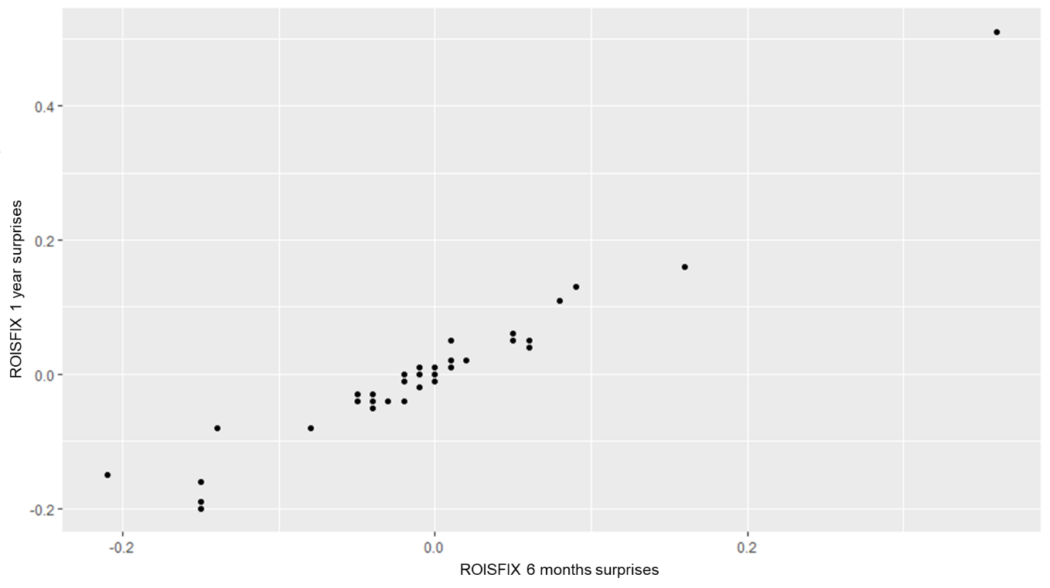

Figure 2. The changes in ROISFIX on monetary policy meeting dates
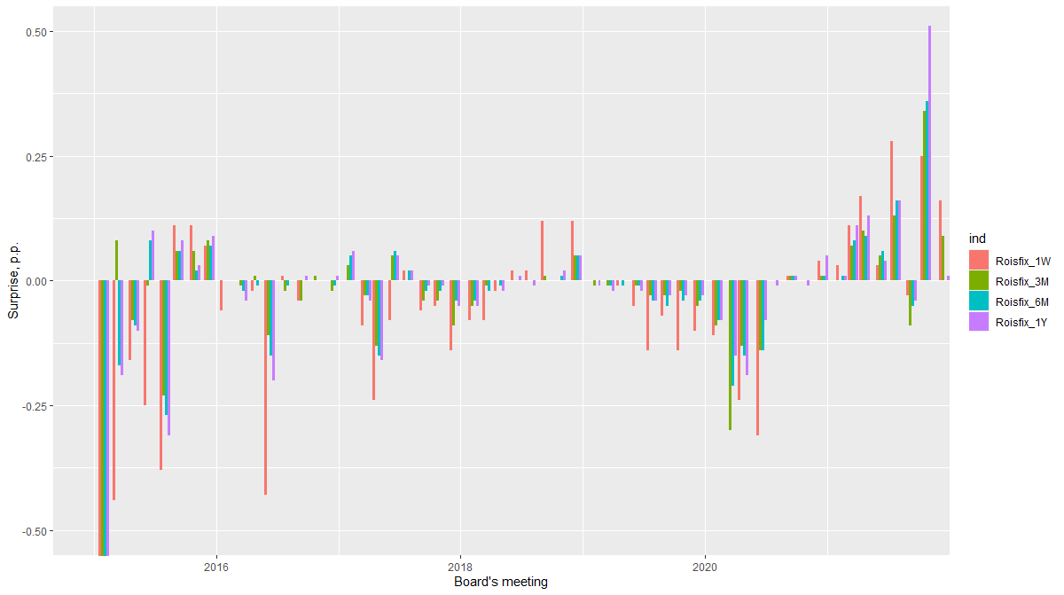

Figure 3. The cumulative changes in ROISFIX on monetary policy meeting dates
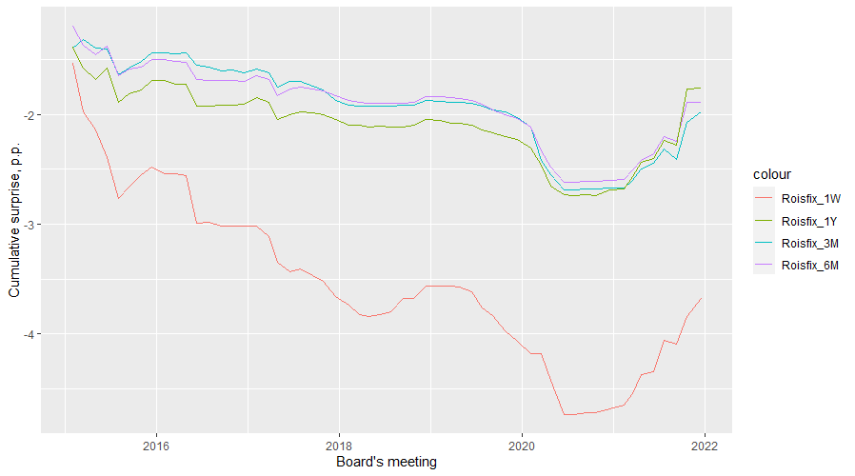

Annex 3. Assessments of models of the high role of uncertainty and information shocks

Model 1. Assessment of the impact of variance of Bloomberg analysts’ forecasts of key macro variables (GDP/inflation/industrial production/real wages/unemployment rate/real retail sales) on the emergence of Bank of Russia monetary policy surprises
 | Dependent variable:
 | Target shock | Path shock | Bloomberg Surprises
GDP | 6.215 | 7.768 | 788.499
 | (3.562) | (3.894) | (884.411)
Inflation | 4.589 | 4.398 | 5,908.793**
 | (5.859) | (6.405) | (1,454.851)
Production | 0.084 | 0.118 | -34.284
 | (0.126) | (0.137) | (31.199)
Salary | -0.007 | 0.034 | 30.621
 | (0.106) | (0.116) | (26.422)
Unemployment | 6.004 | 6.572 | -4,745.463
 | (8.660) | (9.468) | (2,150.572)
Sales | 0.153 | 0.110 | -91.964
 | (0.200) | (0.219) | (49.671)
Constant | -0.220 | -0.246 | 30.468
 | (0.133) | (0.145) | (33.037)
Observations | 10 | 10 | 10
R² | 0.620 | 0.631 | 0.871
Adjusted R² | -0.141 | -0.107 | 0.614
Residual Std. Error | 0.096 (df = 3) | 0.105  (df = 3) | 23.761  (df = 3)
F Statistic | 0.814 (df = 6; 3) | 0.855  (df = 6; 3) | 3.388  (df = 6; 3)
Note: | *p<0.1; **p<0.05; ***p<0.01
Model 2. Assessment of the impact of the News Uncertainty Index (NUI) on the emergence of Bank of Russia monetary policy surprises
 | Dependent variable:
 | Target shock | Path shock | Bloomberg Surprises
NUI | -3.827* | -7.981* | 374.796
 | (2.252) | (4.463) | (268.985)
Constant | -0.110*** | -0.118 | 32.321***
 | (0.039) | (0.077) | (4.620)
Observations | 45 | 45 | 45
R² | 0.063 | 0.069 | 0.043
Adjusted R² | 0.041 | 0.048 | 0.021
Residual Std. Error | 0.254  (df = 43) | 0.504  (df = 43) | 30.388  (df = 43)
F Statistic | 2.886*  (df = 1; 43) | 3.197*  (df = 1; 43) | 1.941  (df = 1; 43)
Note: | *p<0.1; **p<0.05; ***p<0.01

Annex 4. Verbal interventions of the Bank of Russia before decisions
Decision date | Interventions in the period before the decision
30 January 2015 | –
13 March 2015 | Simanovsky  ‘According to the economist, on 13 March, the Central Bank of Russia will decide whether to keep the rate at the current 15 per cent or start reducing it.’  https://bankist.ru/news/2495/?utm_source=yxnews&utm_medium=desktop&utm_referrer=https%3A%2F%2Fyandex.ru%2Fnews%2Fsearch%3Ftext%3D
30 April 2015 | Tulin  ‘Representative of the Central Bank Dmitry Tulin said that the Bank of Russia plans to reduce the current key rate, which is now 14 per cent.’  http://moneyzzz.ru/news/130212/?pl13_sid=130212&utm_source=yxnews&utm_medium=desktop&utm_referrer=https%3A%2F%2Fyandex.ru%2Fnews%2Fsearch%3Ftext%3D
15 June 2015 | –
31 June 2015 | –
11 September 2015 | –
30 October 2015 | –
11 December 2015 | –
29 January 2016 | –
18 March 2016 | –
29 April 2016 | –
10 June 2016 | –
29 July 2016 | –
16 September 2016 | Nabiullina  ‘The head of the Central Bank warned in this regard that the Central Bank’s monetary policy remains ‘moderately tight’ and will remain so in the future.’  https://www.newsru.com/finance/09sep2016/nabiullinasochi.html?utm_source=yxnews&utm_medium=desktop&utm_referrer=https%3A%2F%2Fyandex.ru%2Fnews%2Fsearch%3Ftext%3D
28 October 2016 | –
16 December 2016 | –
3 February 2017 | Yudaeva  ‘Right now, inflation is still above the target, inflation expectations are even more elevated, and for inflation and inflation expectations to come down, real rates need to be 2–3 percentage points above that level.’  https://arb.ru/b2b/interview/kseniya_yudaeva_dlya_nas_tsel_po_inflyatsii_bezuslovnyy_prioritet-10083481/?utm_source=yxnews&utm_medium=desktop&utm_referrer=https%3A%2F%2Fyandex.ru%2Fnews%2Fsearch%3Ftext%3D
24 March 2017 | –
28 April 2017 | Nabiullina  ‘A faster decline in inflation opens up room for us to lower the key rate as early as April. I even assume that at the next Board meeting in a week, there may be a discussion about reducing the rate by between 25 and 50 basis points.’  https://1prime.ru/experts/20170426/827406114.html?utm_source=yxnews&utm_medium=desktop&utm_referrer=https%3A%2F%2Fyandex.ru%2Fnews%2Fsearch%3Ftext%3D
16 June 2017 | Nabiullina  ‘We will consider two options (a 25 bp and a 50 bp reduction). We will make our decision on the basis of the traditional analysis of inflation indicators, inflation expectations, the situation in the economy, and unemployment. There is now intensive preparation for this meeting in progress, and we will be choosing’  http://www.finmarket.ru/analytics/4549003?utm_source=yxnews&utm_medium=desktop&utm_referrer=https%3A%2F%2Fyandex.ru%2Fnews%2Fsearch%3Ftext%3D
28 July 2017 | –
15 September 2017 | Nabiullina  The Bank of Russia sees room for a key rate reduction, most likely, discussion will proceed between rate reductions of 0.25 pp and 0.5 pp, said the regulator’s head Elvira Nabiullina in an interview with Bloomberg on 7 September.  https://ria.ru/20170913/1504720574.html?utm_source=yxnews&utm_medium=desktop&utm_referrer=https%3A%2F%2Fyandex.ru%2Fnews%2Fsearch%3Ftext%3D
27 October 2017 | –
15 December 2017 | Nabiullina  At the end of November, Central Bank governor Elvira Nabiullina said that the recent slowdown in inflation was due to a stronger ruble on the back of rising oil prices and a record grain harvest. At the same time, she once again confirmed that the recently observed inflation rate does not require a correction of monetary policy, since low inflation rates are largely due to ‘positive factors that can exhaust their effect’, and in general, inflation is ‘near the target.’  https://www.finam.ru/analysis/marketnews/bank-rossii-soxranit-umerenno-zhestkie-formulirovki-20171213-14400/?utm_source=yxnews&utm_medium=desktop&utm_referrer=https%3A%2F%2Fyandex.ru%2Fnews%2Fsearch%3Ftext%3D
9 February 2018 | Nabiullina  ‘We see room for a softening of monetary policy. And, of course, the size of the step will be considered next week and at the board meeting. But now we see that the devaluation risks associated with external factors have weakened, so we do not exclude that we will move to a neutral monetary policy a little faster than we had previously assumed’  https://www.interfax.ru/amp/598052
23 March 2018 | –
27 April 2018 | Dmitriev  ‘We are talking about approaching the neutralisation point. And then, depending on the inflation forecast and on how short-term trends develop, the question is whether we will remain at this point of neutralisation. The restriction on the impossibility of increasing the rate is already lifted. Depending on the inflation forecast it may go up, may go down, or may spend some time around neutral levels’  https://1prime.ru/articles/20180416/828721682.html
15 June 2018 | –
27 July 2018 | –
14 September 2018 | Nabiullina  ‘There are few factors right now that would speak in favour of a rate reduction. There are a significant number of factors that speak in favour of keeping the rate, and several factors have emerged that allow the question of a possible rate increase to be put on the table.’  https://www.dp.ru/a/2018/09/09/Gadanie_na_infljacii?utm_source=yxnews&utm_medium=desktop&utm_referrer=https%3A%2F%2Fyandex.ru%2Fnews%2Fsearch%3Ftext%3D
26 October 2018 | –
14 December 2018 | –
8 February 2019 | –
22 March 2019 | several statements  https://www.finam.ru/analysis/marketnews/centrobank-smyagchit-svoyu-ritoriku-v-otnoshenii-inflyacii-20190320-15400/?utm_source=yxnews&utm_medium=desktop&utm_referrer=https%3A%2F%2Fyandex.ru%2Fnews%2Fsearch%3Ftext%3D
26 April 2019 | –
14 June 2019 | Nabiullina  ‘We believe it is possible to return to rate reduction in Q2 or Q3,’ she stressed, noting that ‘the pro-inflationary factors that required our intervention have largely exhausted themselves.’  http://duma.gov.ru/news/45159/
26 July 2019 | Nabiullina  At the beginning of July, the regulator’s head, Elvira Nabiullina, did not rule out that the key rate could be lowered by 50 bp at once.  https://www.banki.ru/news/lenta/?id=10901975&r1=rss&r2=yandex.news&utm_source=yxnews&utm_medium=desktop&utm_referrer=https%3A%2F%2Fyandex.ru%2Fnews%2Fsearch%3Ftext%3D
6 September 2019 | –
25 October 2019 | Nabiullina  ‘We see that our key rate may be not just reduced, but that we can act more decisively’  http://www.finmarket.ru/analytics/5102350?utm_source=yxnews&utm_medium=desktop&utm_referrer=https%3A%2F%2Fyandex.ru%2Fnews%2Fsearch%3Ftext%3D
13 December 2019 | –
7 February 2020 | –
20 March 2020 | –
24 April 2020 | Nabiullina  According to Central Bank head Elvira Nabiullina, a rate increase is unlikely, and the possibility of a rate cut is the main option to be considered on 24 April.  https://www.banki.ru/news/lenta/?id=10922795&utm_source=yxnews&utm_medium=desktop&utm_referrer=https%3A%2F%2Fyandex.ru%2Fnews%2Fsearch%3Ftext%3D
19 June 2020 | Nabiullina  In public speeches in May and early June, the Central Bank head, Elvira Nabiullina, June repeatedly pointed to the room for significant further monetary policy softening and even noted that one of the options at the June meeting would be to reduce the rate by 100 bp at once – from 5.5% to 4.5%.  https://www.banki.ru/news/lenta/?id=10927042&utm_source=yxnews&utm_medium=desktop&utm_referrer=https%3A%2F%2Fyandex.ru%2Fnews%2Fsearch%3Ftext%3D
24 July 2020 | Nabiullina  ‘We now have the opportunity to lower the key rate based on low inflation’  https://www.rbc.ru/rbcfreenews/5f0c6d3f9a794768a912993f
18 September 2020 | Nabiullina  On 8 September, speaking at the Moscow Financial Forum, E. Nabiullina reported that the Central Bank will assess not only when to use this room to soften monetary policy, but also the appropriateness of using this space in general.  https://www.finam.ru/analysis/forecasts/klyuchevaya-stavka-cb-rf-v-preddverii-zasedaniya-soveta-direktorov-20200914-120157/?utm_source=yxnews&utm_medium=desktop&utm_referrer=https%3A%2F%2Fyandex.ru%2Fnews%2Fsearch%3Ftext%3D
23 October 2020 | Zabotkin  An interview with Alexey Zabotkin, Deputy Governor of the Bank of Russia, made it clear that no changes are to be expected from the next meeting. The deputy head of the Central Bank of Russia said that the same factors as before will be taken into account when making a decision on the rate in October. On the basis of this message, it can be concluded that the rate will remain unchanged.  https://exp.idk.ru/news/politika/cb-rf-otlozhit-snizhenie-klyuchevoj-stavki-do-dekabrya-prognoz-ehkspertov/533677/?utm_source=yxnews&utm_medium=desktop&utm_referrer=https%3A%2F%2Fyandex.ru%2Fnews%2Fsearch%3Ftext%3D
18 December 2020 | Nabiullina  ‘This gives us room for additional policy softening, but the decision depends on many factors. The situation is very uncertain.’  https://www.interfax.ru/business/740549
12 February 2021 | –
19 March 2021 | –
23 April 2021 | –
11 June 2021 | Yudaeva  On 11 June, the Central Bank’s Board of Directors will consider options to raise the rate by 25 or 50 bp. There is less chance of keeping the rate unchanged, said First Deputy Governor of the Bank of Russia Ksenia Yudaeva last week.  https://www.interfax.ru/business/771420
23 July 2021 | Nabiullina  ‘We will carefully study the new data, revise our forecast in July and make a decision on the size of the step. I think we can discuss an increase of from 25 basis points to 1 percentage point’  https://www.rbc.ru/finances/28/06/2021/60d98e6f9a794782ab56d932
10 September 2021 | –
22 October 2021 | –
17 December 2021 | Zabotkin  “25 bp move is unlikely”  https://marketnews.com/cbr-s-zabotkin-cbr-considering-wide-range-of-hiking-options-25bp-unlikely

Annex 5. Forecast and forecasting error charts

Inflation forecasts for the current year | Forecasting errors
Inflation forecasts for the next year | Forecasting errors
Inflation forecasts for two years | Forecasting errors

Annex 6. Results of evaluation of the forecast rationality hypothesis

Figure 1. Scatter diagrams of inflation forecasts

Note: X axis – inflation forecasts of the Bank of Russia and analysts; Y axis – actual inflation.
Table 1. Mean squared errors of inflation forecasts
Forecasts | Bank of Russia | Analysts
For the current year | 1.46 | 2.84
For the next year | 3.11 | 3.04
For the next two years | 4.08 | 2.97

Results of regression evaluation. Rationality of inflation forecasts of the Bank of Russia
$π= α+{β\hat{π}}_{BR }+ε$
where π – the actual inflation,
${\hat{π}}_{BR}$ – the Bank of Russia’s inflation forecast.

Table 2. Results of regression evaluation (Bank of Russia)

 | Forecasts for the current year |  | Forecasts for the next year |  |  | Forecasts for  two years
 | Dependent  variable: |  | Dependent variable: |  |  | Dependent  variable:
 | Fact |  | Fact |  |  | Fact
BR | 1.063*** |  | 0.040 |  |  | -10.139***
 | (0.047) |  | (0.725) |  |  | (3.970)
Constant | -0.231 |  | 4.427* |  |  | 45.083***
 | (0.566) |  | (3.703) |  |  | (16.673)
Observations | 28 |  | 24 |  |  | 19
R² | 0.871 |  | 0.0003 |  |  | 0.055
Adjusted R² | 0.866 |  | -0.045 |  |  | -0.001
Residual Std. Error | 1.255  (df = 26) |  | 1.841  (df = 22) |  |  | 1.991  (df = 17)
F Statistic | 175.644***  (df = 1; 26) |  | 0.007  (df = 1; 22) |  |  | 0.982  (df = 1; 17)
Note: | *p<0.1; **p<0.05; ***p<0.01
F-test to evaluate the rationality of Bank of Russia forecasts
Hypothesis being tested: α = 0 and β = 1.
Table 3. F-test results (Bank of Russia)
Forecasts for the current year:
Statistic | N | Mean | St. Dev. | Min | Pctl(25) | Pctl(75) | Max
Res.Df | 2 | 27.000 | 1.414 | 26 | 26.5 | 27.5 | 28
Df | 1 | 2.000 |  | 2.000 | 2.000 | 2.000 | 2.000
F | 1 | 2.094 |  | 2.094 | 2.094 | 2.094 | 2.094
Pr(> F) | 1 | 0.144 |  | 0.144 | 0.144 | 0.144 | 0.144

Forecasts for the next year:
Statistic | N | Mean | St. Dev. | Min | Pctl(25) | Pctl(75) | Max
Res.Df | 2 | 23.000 | 1.414 | 22 | 22.5 | 23.5 | 24
Df | 1 | 2.000 |  | 2.000 | 2.000 | 2.000 | 2.000
F | 1 | 1.536 |  | 1.536 | 1.536 | 1.536 | 1.536
Pr(> F) | 1 | 0.237 |  | 0.237 | 0.237 | 0.237 | 0.237

Forecasts for two years:
Statistic | N | Mean | St. Dev. | Min | Pctl (25) | Pctl (75) | Max
Res.Df | 2 | 18.000 | 1.414 | 17 | 17.5 | 18.5 | 19
Df | 1 | 2.000 |  | 2.000 | 2.000 | 2.000 | 2.000
F | 1 | -192,144,435,630.000 |  | -192,144,435,630.000 | -192,144,435,630.000 | -192,144,435,630.000 | -192,144,435,630.000
Pr(> F) | 1 | 1.000 |  | 1.000 | 1.000 | 1.000 | 1.000

The hypothesis that α = 0 and β = 1 cannot be rejected for forecasts for the current year. For other forecasts the assumption of a normal distribution of residuals is not fulfilled.

Results of regression evaluation. Rationality of analysts’ inflation forecasts
$π= α+{β\hat{π}}_{Analysts} +ε$
where π – the actual inflation,
${\hat{π}}_{Analysts }$ – the analysts’ inflation forecast (Bloomberg consensus).
Table 4. Results of regression evaluation (analysts)

 | Forecasts for the current year |  | Forecasts for the next year |  |  | Forecasts for  two years
 | Dependent  variable: |  | Dependent variable: |  |  | Dependent  variable:
 | Fact |  | Fact |  |  | Fact
Analysts | 0.752*** |  | -0.189 |  |  | -1.074**
 | (0.054) |  | (0.321) |  |  | (0.376)
Constant | 1.100 |  | 5.526*** |  |  | 9.743***
 | (0.822) |  | (2.068) |  |  | (1.841)
Observations | 28 |  | 24 |  |  | 20
R² | 0.749 |  | 0.021 |  |  | 0.311
Adjusted R² | 0.740 |  | -0.024 |  |  | 0.273
Residual Std. Error | 1.750  (df = 26) |  | 1.822  (df = 22) |  |  | 1.817  (df = 18)
F Statistic | 77.656***  (df = 1; 26) |  | 0.469  (df = 1; 22) |  |  | 8.143**  (df = 1; 18)
Note: | *p<0.1; **p<0.05; ***p<0.01
F-test results to evaluate the rationality of analysts’ forecasts
Hypothesis being tested: α = 0 and β = 1.
Table 5. F-test results (analysts)
Forecasts for the current year:
Statistic | N | Mean | St. Dev. | Min | Pctl(25) | Pctl(75) | Max
Res.Df | 2 | 27.000 | 1.414 | 26 | 26.5 | 27.5 | 28
Df | 1 | 2.000 |  | 2.000 | 2.000 | 2.000 | 2.000
F | 1 | 22.970 |  | 22.970 | 22.970 | 22.970 | 22.970
Pr(> F) | 1 | 0.00000 |  | 0.00000 | 0.00000 | 0.00000 | 0.00000

Forecasts for the next year:
Statistic | N | Mean | St. Dev. | Min | Pctl(25) | Pctl(75) | Max
Res.Df | 2 | 23.000 | 1.414 | 22 | 22.5 | 23.5 | 24
Df | 1 | 2.000 |  | 2.000 | 2.000 | 2.000 | 2.000
F | 1 | 13.817 |  | 13.817 | 13.817 | 13.817 | 13.817
Pr(> F) | 1 | 0.0001 |  | 0.0001 | 0.0001 | 0.0001 | 0.0001

Forecasts for two years:
Statistic | N | Mean | St. Dev. | Min | Pctl(25) | Pctl(75) | Max
Res.Df | 2 | 19.000 | 1.414 | 18 | 18.5 | 19.5 | 20
Df | 1 | 2.000 |  | 2.000 | 2.000 | 2.000 | 2.000
F | 1 | 3,968.119 |  | 3,968.119 | 3,968.119 | 3,968.119 | 3,968.119
Pr(> F) | 1 | 0.000 |  | 0.000 | 0.000 | 0.000 | 0.000

The hypothesis that α = 0 and β = 1 is rejected for all forecast horizons.

Annex 7. Evaluation of regressions for the Bank of Russia information advantage hypothesis
$$π= α+β_{1}{\hat{π}}_{BR}+β_{2}{\hat{π}}_{Analysts} +ε$$
where π – the actual inflation,
${\hat{π}}_{BR}$– the Bank of Russia’s inflation forecast,
${\hat{π}}_{Analysts}$ – the analysts’ inflation forecast (Bloomberg consensus).

Table 1. Results of regression evaluation.
 | Forecasts for the current year |  | Forecasts for the next year |  |  | Forecasts for  two years
 | Dependent  variable: |  | Dependent variable: |  |  | Dependent  variable:
 | Fact |  | Fact |  |  | Fact
Analysts | -0.293 |  | -0.483 |  |  | -0.838***
 | (0.212) |  | (0.332) |  |  | (0.242)
BR | 1.431*** |  | 0.584 |  |  | -0.377
 | (0.241) |  | (0.955) |  |  | (0.857)
Constant | -0.490 |  | 4.385 |  |  | 9.779**
 | (0.402) |  | (3.768) |  |  | (1.959)
Observations | 28 |  | 24 |  |  | 18
R² | 0.881 |  | 0.063 |  |  | 0.287
Adjusted R² | 0.871 |  | -0.026 |  |  | 0.192
Residual Std. Error | 1.232  (df = 25) |  | 1.824  (df = 21) |  |  | 1.611  (df = 15)
F Statistic | 92.136***  (df = 2; 25) |  | 0.705  (df = 2; 21) |  |  | 3.024*  (df = 2; 15)
Note: | *p<0.1; **p<0.05; ***p<0.01

The coefficient for Bank of Russia forecasts is significantly different from zero only for short-term forecasts (at the end of the current year).

Figure 1. Evaluation of information advantage by rolling window method
Note: the X-axis shows the central observations for each window. The window size is 16. The sample for the current year forecasts includes observations from 2015 to 2021. The samples for the next year forecasts include forecasts until 2020.

Annex 8. Evaluation of regressions for the hypothesis of the influence of monetary policy decisions on analysts’ forecasts
$${∆\hat{π}}_{Analysts}= α+β_{1}Decision+β_{2}{∆\hat{π}}_{BR} +ε$$
where ${∆\hat{π}}_{Analysts}$– the difference between the analysts’ forecasts one week after the key rate decisions and the day before;
${∆\hat{π}}_{BR}$– the difference between the current and previous Bank of Russia inflation forecasts;
Decision – a key rate decision (dummy variable).
Table 1. Results of regression evaluation.
 | Forecasts for the current year |  | Forecasts for the next year |  |  | Forecasts for  two years
 | Dependent  variable: |  | Dependent variable: |  |  | Dependent  variable:
 | Delta_Analysts |  | Delta_Analysts |  |  | Delta_Analysts
Decision_dummy | 0.073** |  | 0.029*** |  |  | -0.006
 | (0.029) |  | (0.008) |  |  | (0.010)
Delta_BR | 0.020 |  | 0.007 |  |  | -0.002
 | (0.014) |  | (0.010) |  |  | (0.006)
Constant | 0.012 |  | 0.003 |  |  | -0.009
 | (0.024) |  | (0.007) |  |  | (0.007)
Observations | 29 |  | 29 |  |  | 24
R² | 0.277 |  | 0.242 |  |  | 0.008
Adjusted R² | 0.221 |  | 0.183 |  |  | -0.086
Residual Std. Error | 0.118  (df = 26) |  | 0.044  (df = 26) |  |  | 0.062  (df = 21)
F Statistic | 4.975**  (df = 2; 26) |  | 4.145**  (df = 2; 26) |  |  | 0.086  (df = 2; 21)
Note: | *p<0.1; **p<0.05; ***p<0.01

The coefficient for Bank of Russia decisions is significantly different from zero for the short- and medium-term forecasts (at the end of the current year and next year).

https://www.imf.org/en/Publications/WEO/Issues/2018/09/24/world-economic-outlook-october-2018
https://www.vedomosti.ru/opinion/articles/2019/05/05/800716-kommunikatsii-tsb-rinkom https://www.vesti.ru/finance/article/2538788 https://www.interfax.ru/business/629292 https://1prime.ru/experts/20210322/833291029.html https://www.kommersant.ru/doc/4790670 https://www.forbes.ru/finansy-i-investicii/424057-yastrebinoe-reshenie-pochemu-cb-pomenyal-svoyu-politiku
ROISfix – RUONIA Overnight Interest Rate Swap – is the indicative rate (fixing) for interest rate swap operations on the RUONIA rate. It is published daily at 12.30 on the basis of a morning survey of the largest banks. For more information, please see the association’s website http://roisfix.ru/.
However, for four meetings, the window was more than two days, and for two meetings, it was less, since either they were held not on a Friday or there were public holidays.
In particular, on 30 January 2015, when the Bank of Russia unexpectedly reduced the rate by 200 bp from 17.00% to 15.00% per annum, the surprise was from -1.20 to -1.54 pp.
The Bank of Russia unexpectedly reduced the rate by 50 bp from 11.00% to 10.50% after it had been unchanged for almost a year.
For a technical description of the composition of the rotation matrix and its multiplication by components, see Annex 1 to the article by Gurkaynak et al. (2005).
Dynamics of the ruble exchange rate. ’Head of the Department of Monetary Policy of the Central Bank – on currency purchases and interest rates’. 2019. Rossiyskaya Gazeta. No. 5(7763).
Central Bank of the Russian Federation: decisions on the rate depend on market conditions // Rambler. – 2018. – 15 October.
About or more than 25 b.p.

